

DXC RealTime Projects

AZ-900, DP - 203



June 10, 2022

[ DXC Technology.pvt]

Name: Thopucherla Sujith

Reg No: DXC262AB12010

**Project1 Name: Smart Vehicles**

Date: 10-06-2022

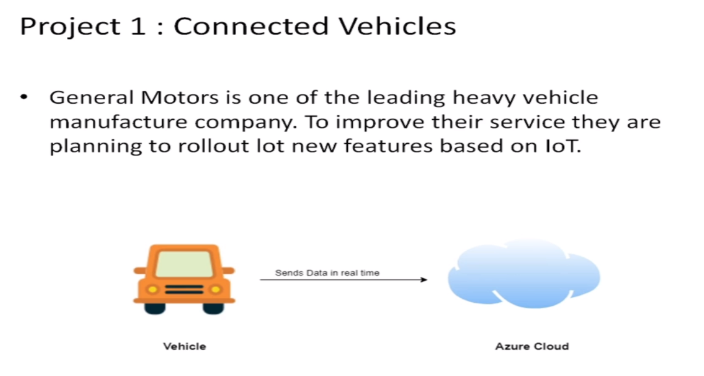

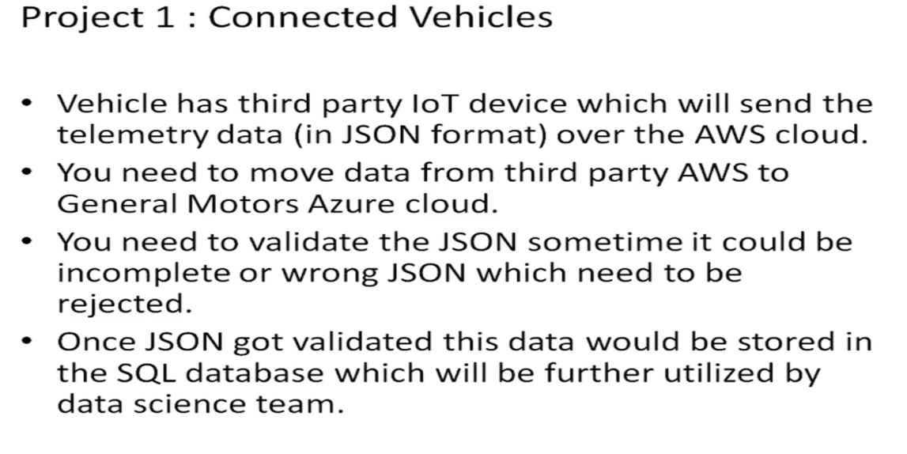

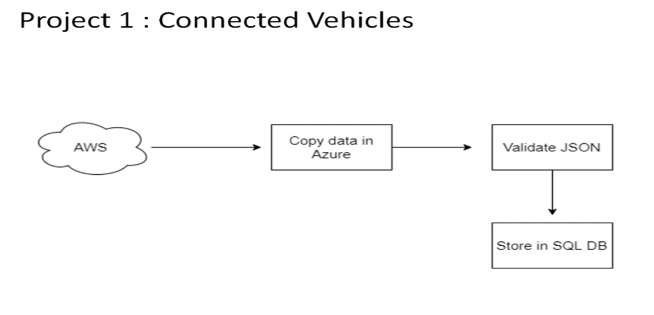

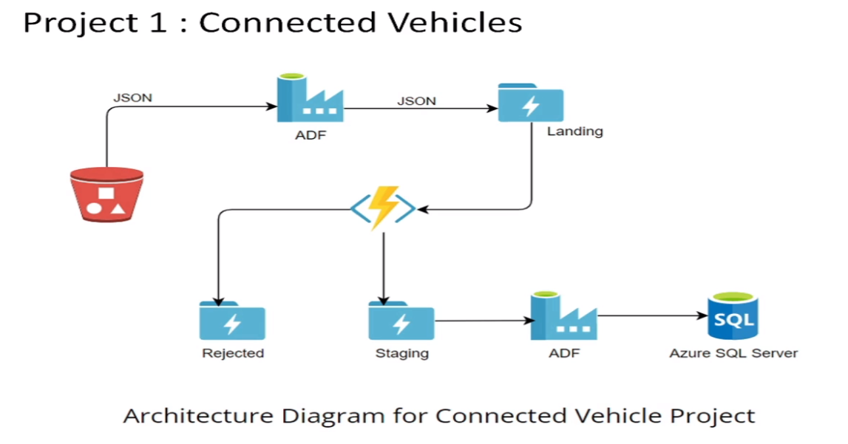

Practical Lab: Create **Azure Data Factory** Account For Data pipelines

Step-1: login to your azure portal and create a resource group.

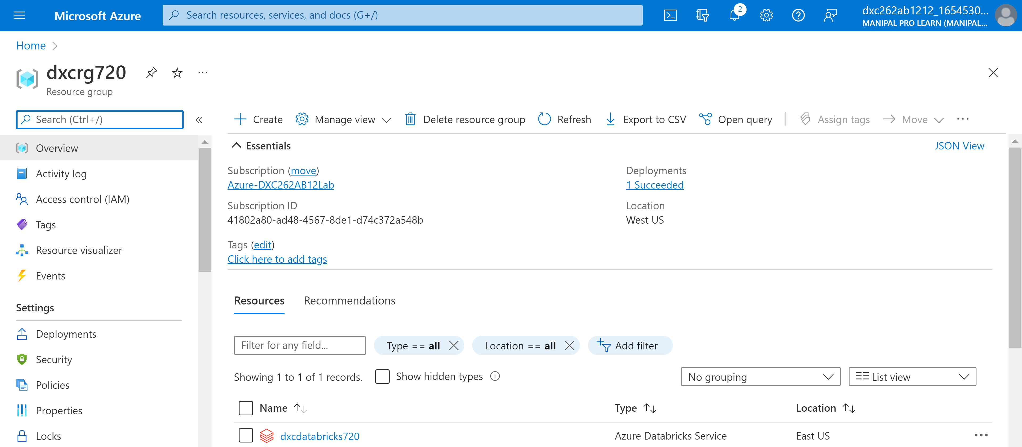

Step-2: Next Go-to search bar and search for data factory.

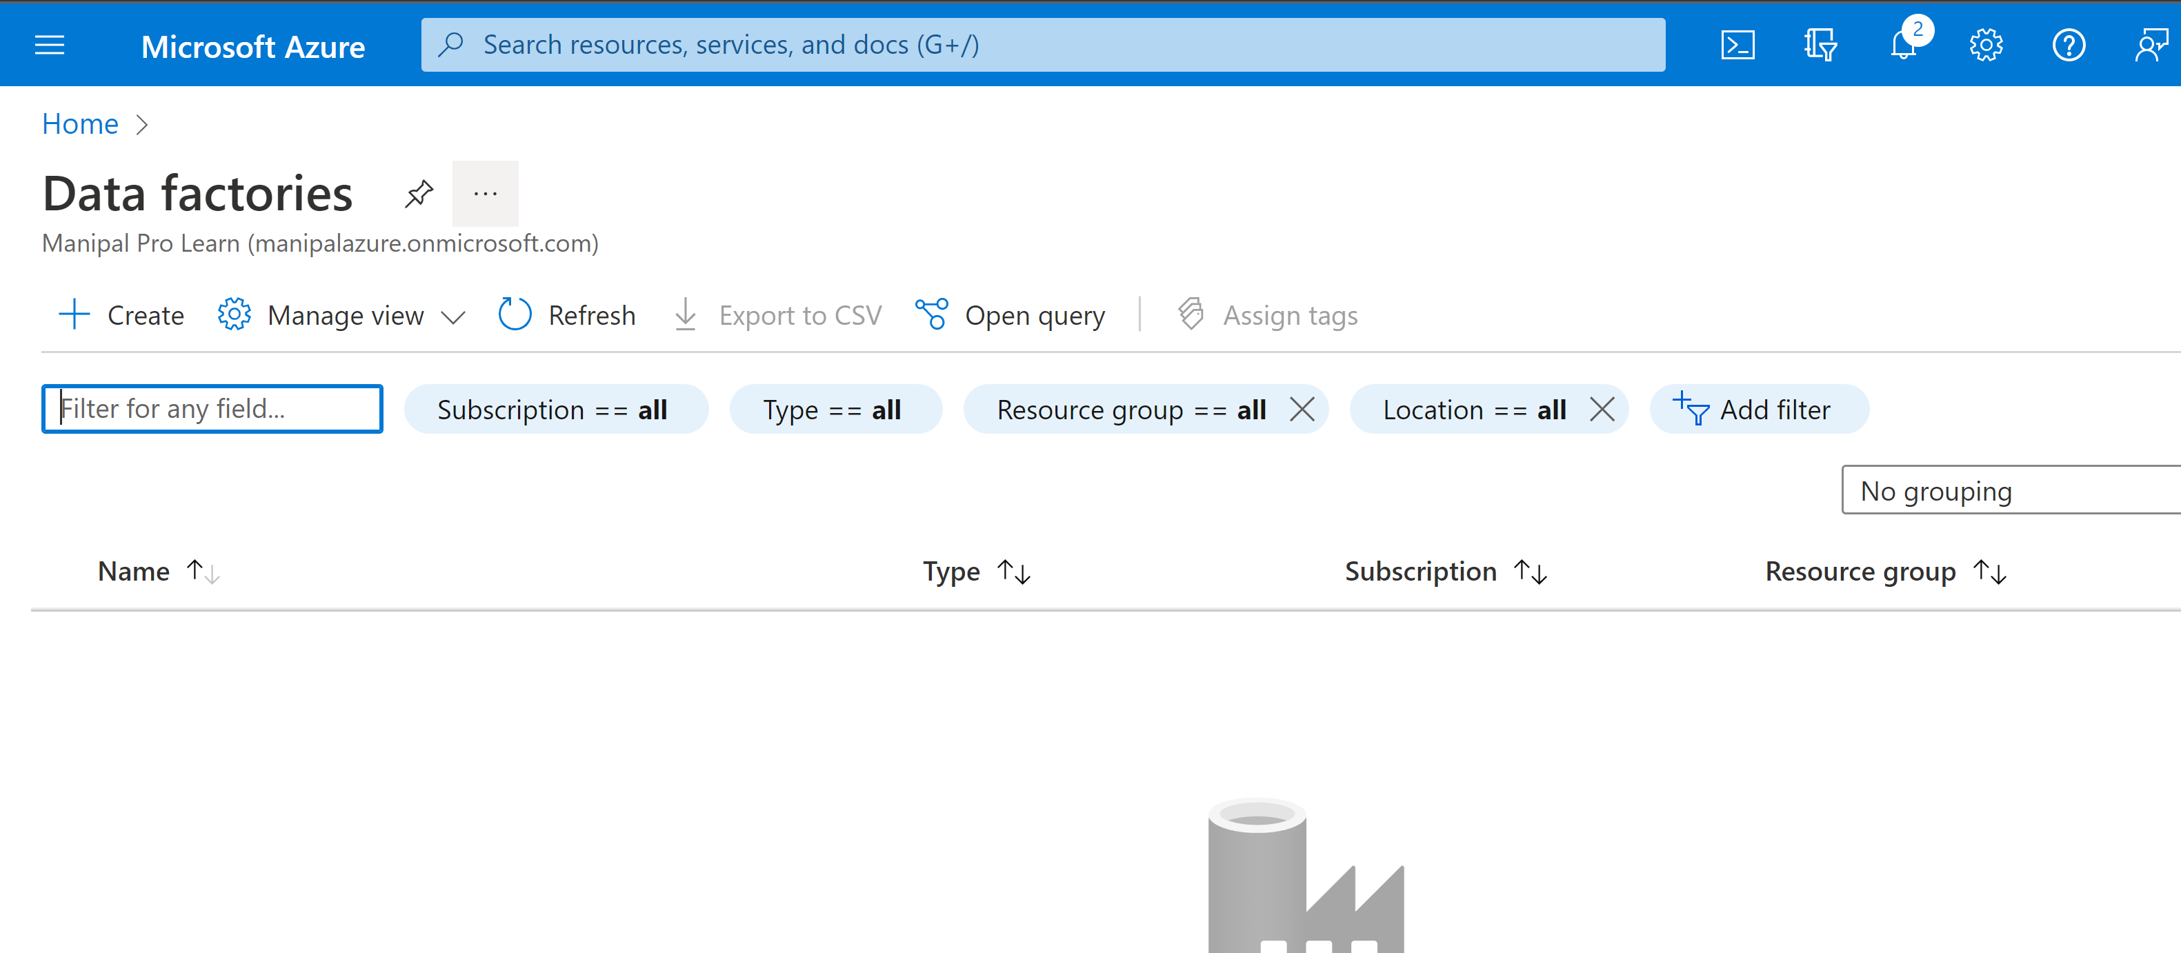

Step-3: Now click on create for creating new data factory and

Now select resource group and name the data factory and click on Review+create.

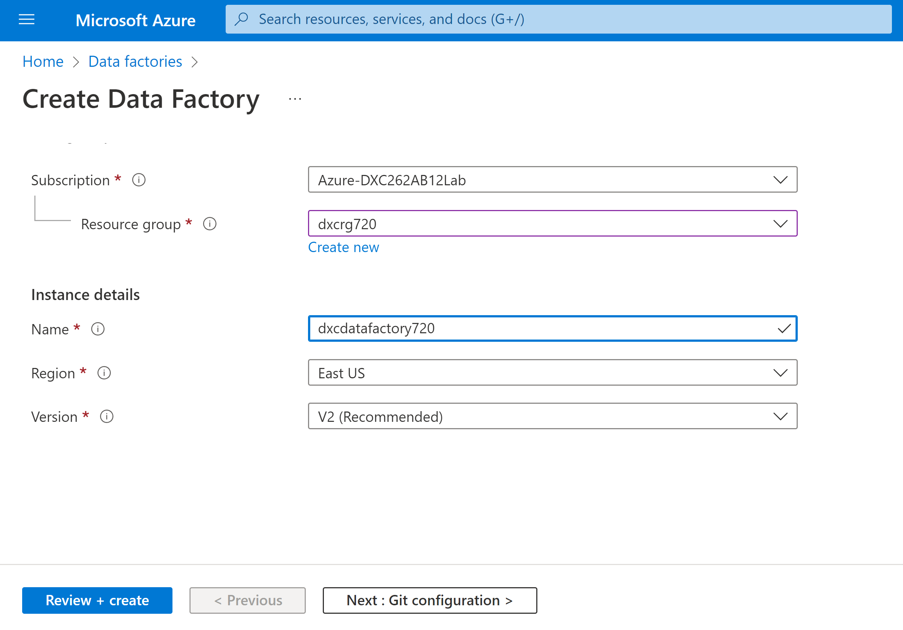

Step-4: After successful creation of data factory click on resourses and open azure data factory studio.

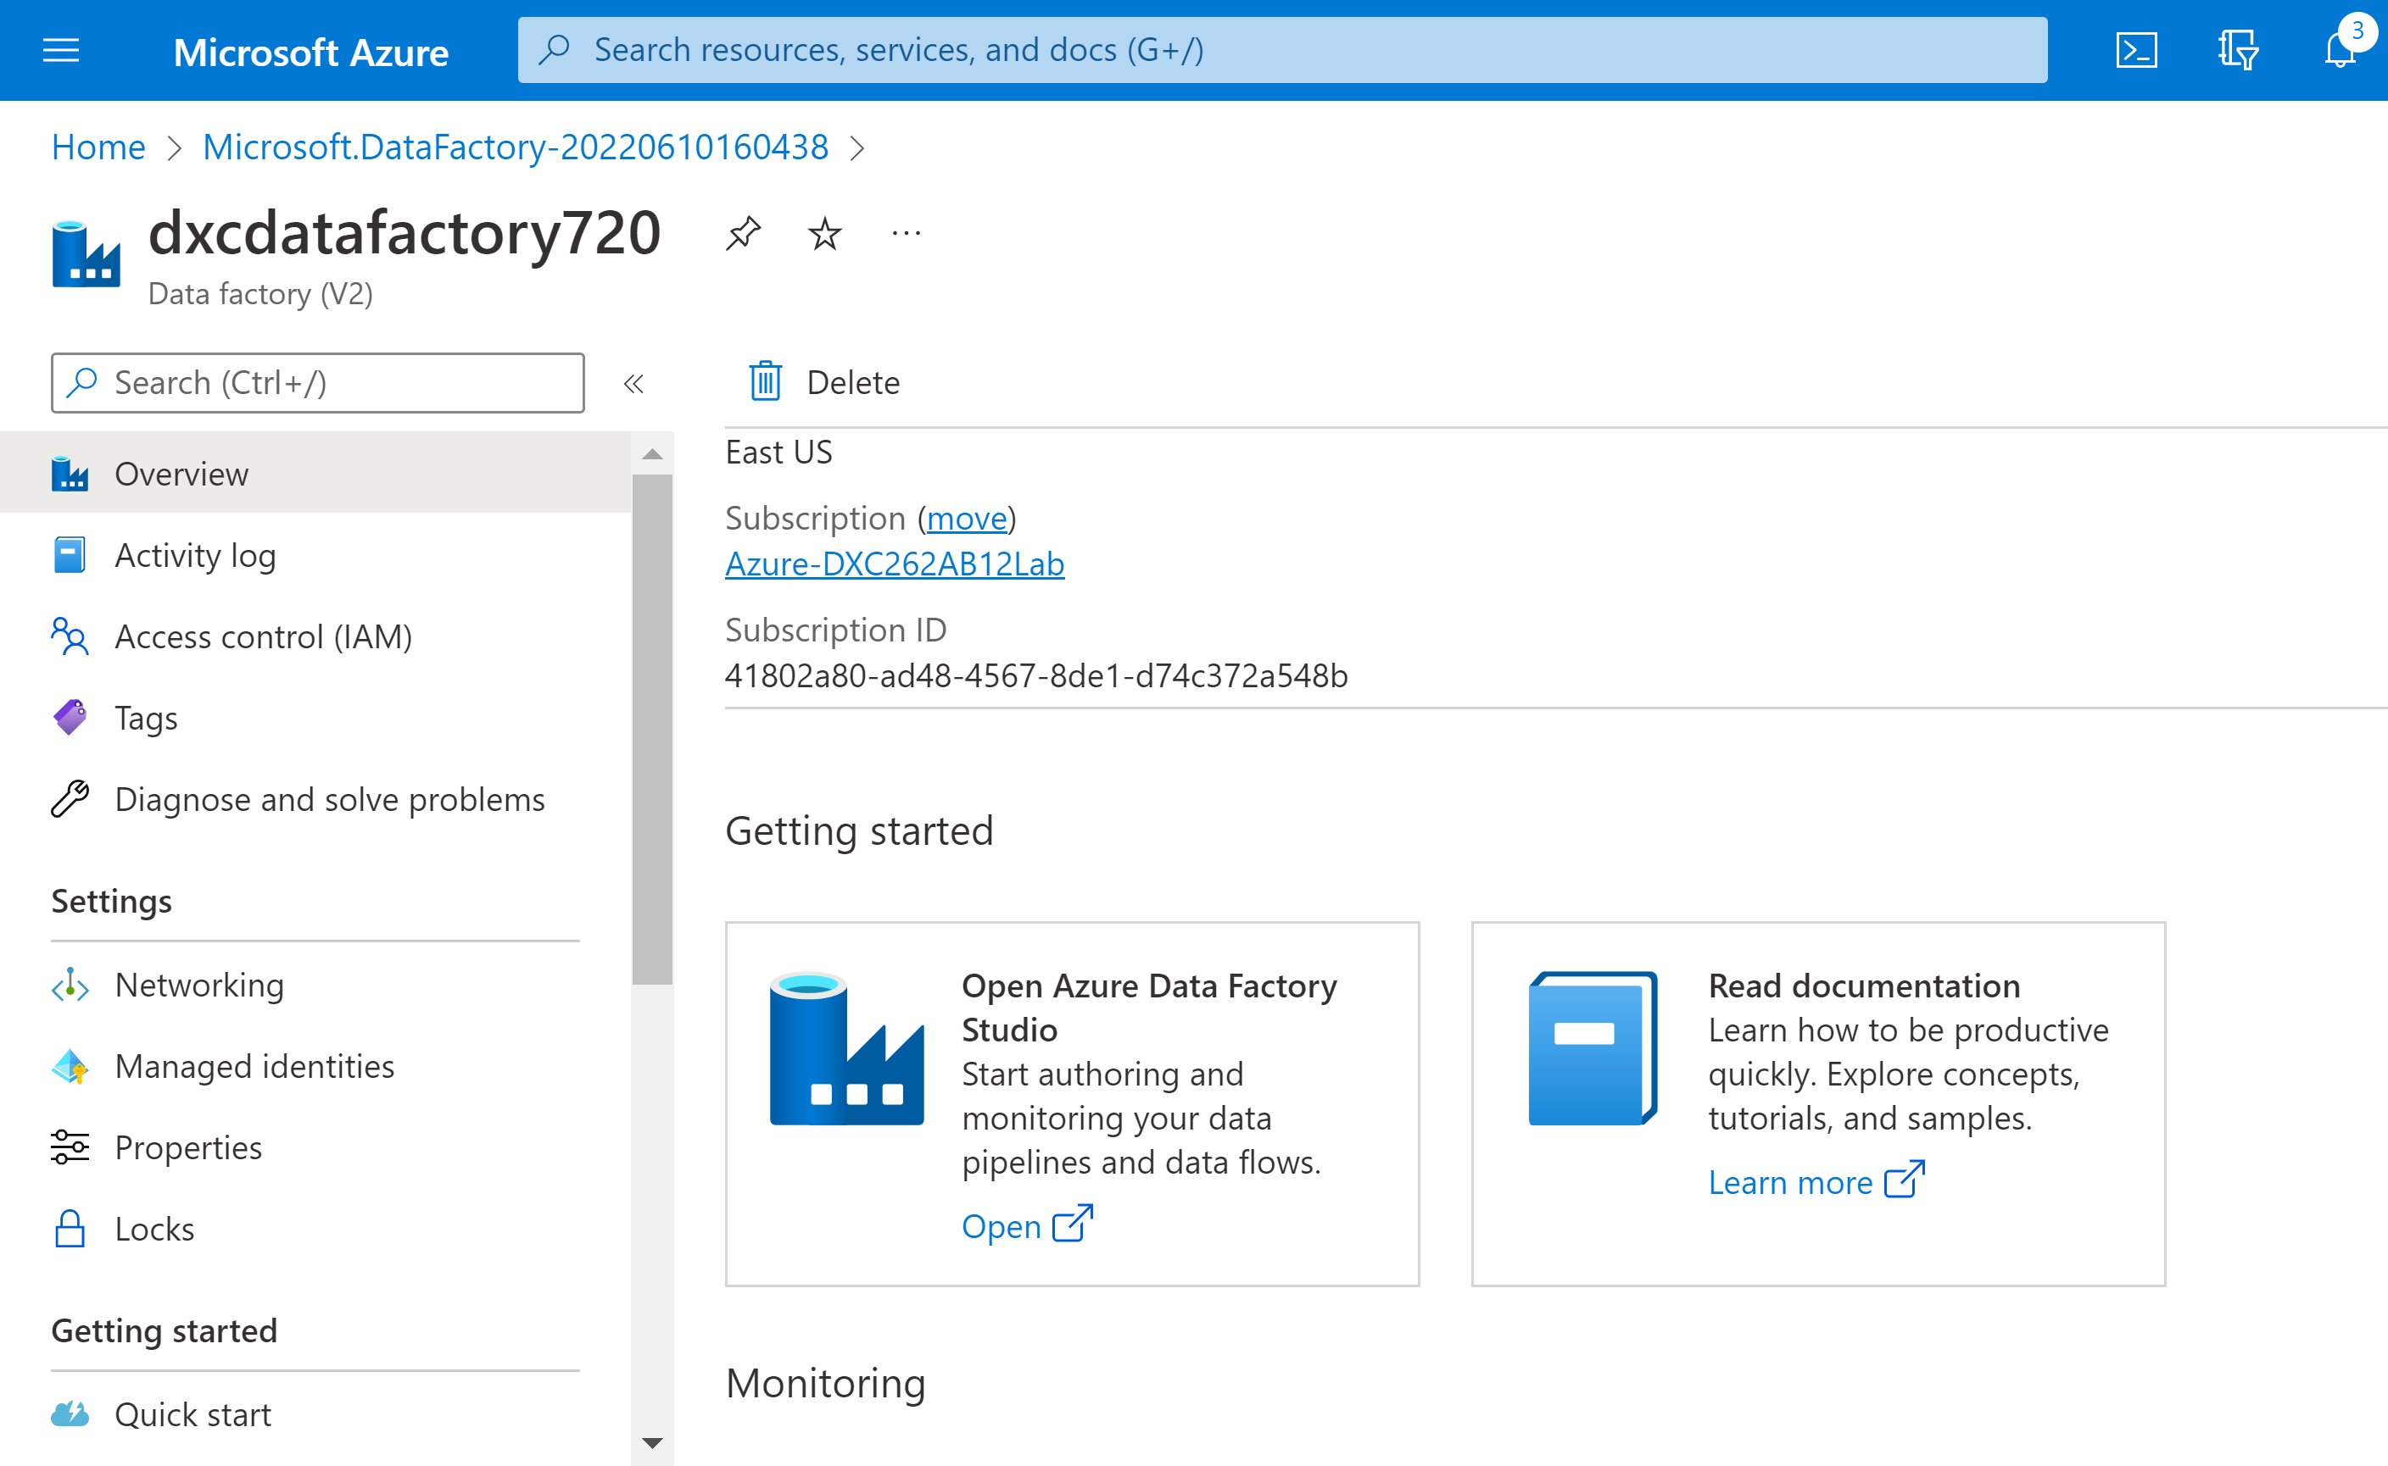

Practical Lab: Create **ADF Pipeline** End to end pipeline with triggers enabled

Step-1: first create a storage account.

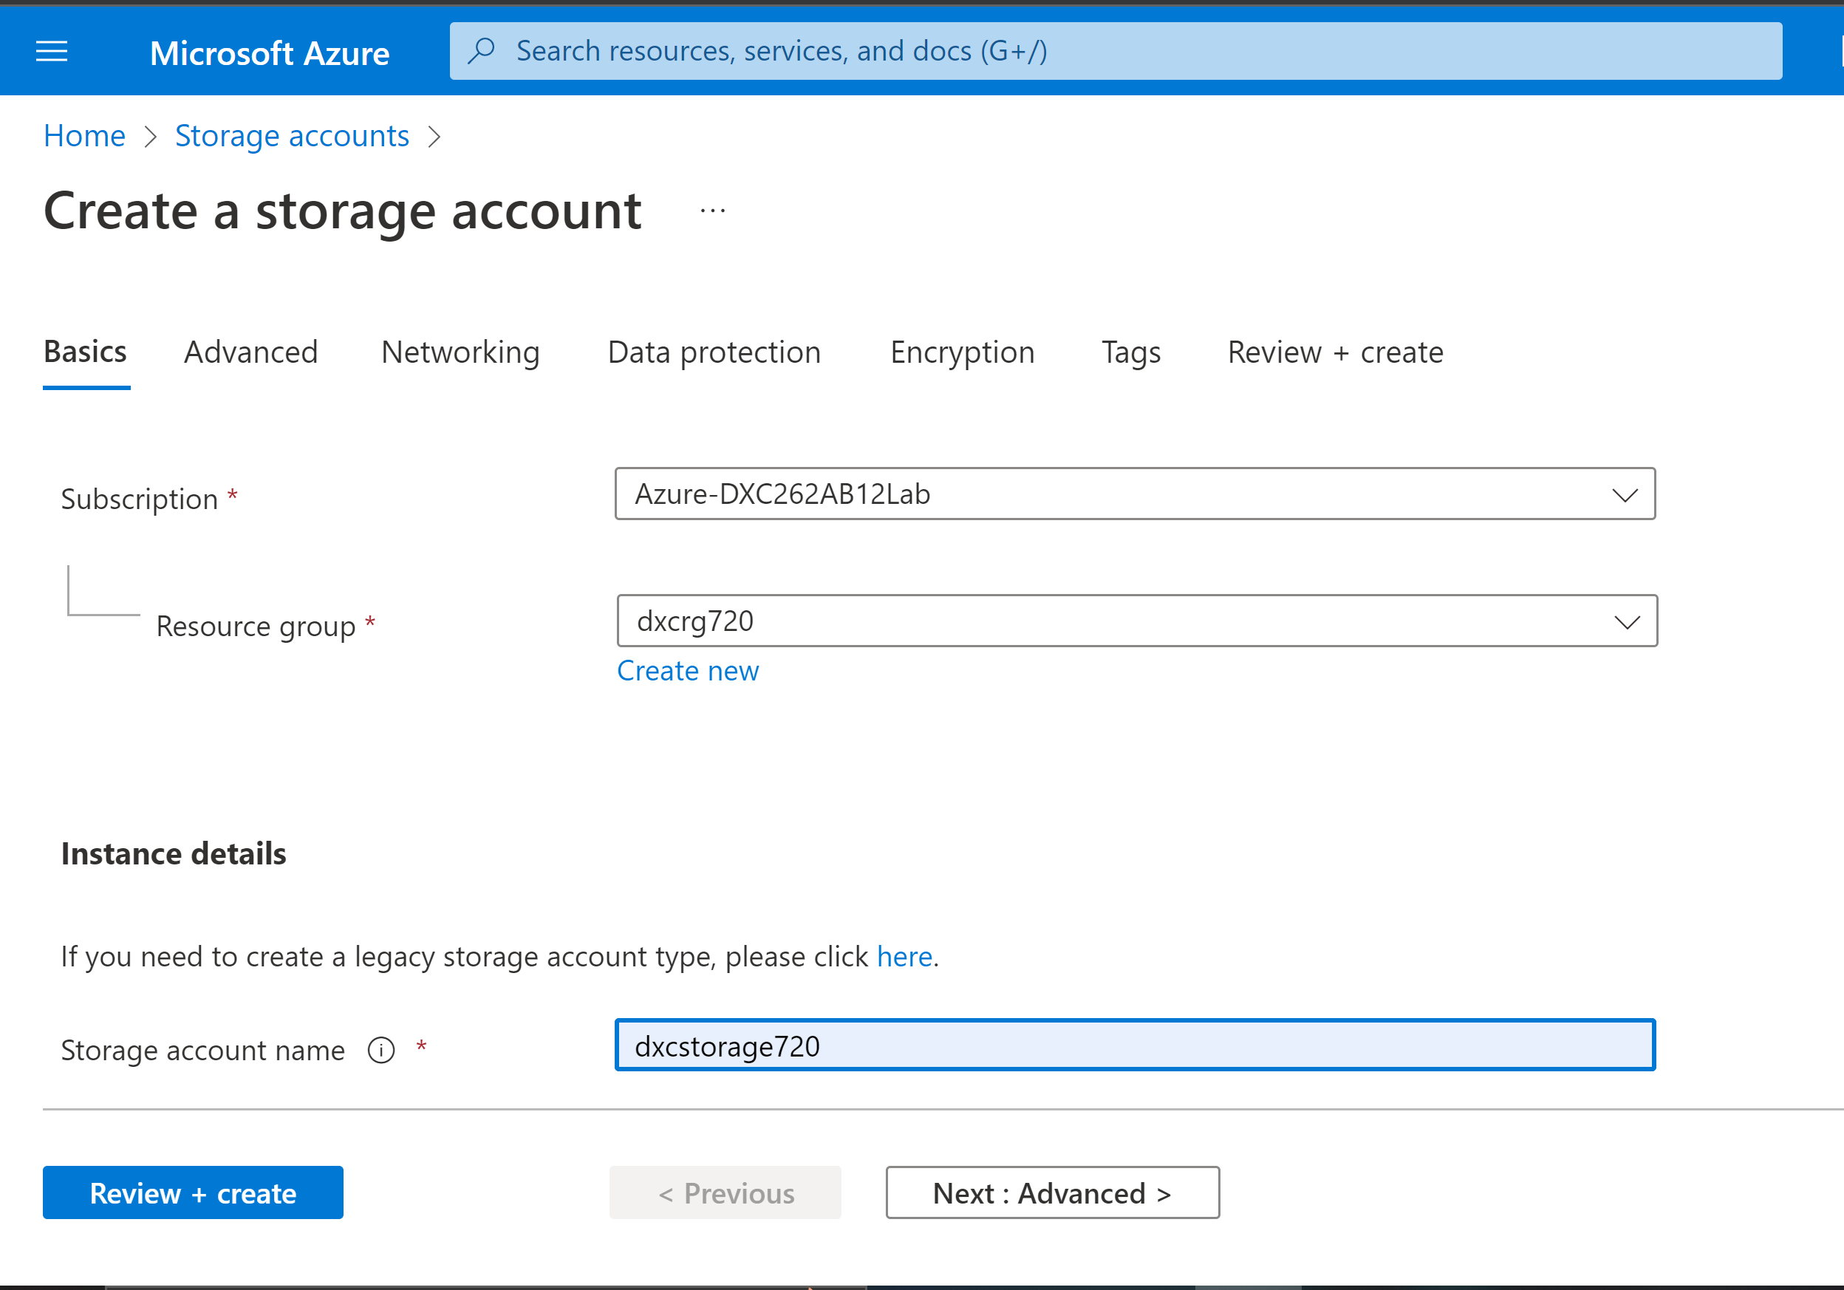

Step-2: after successful creation of storage account create two containers i.e, input and output.

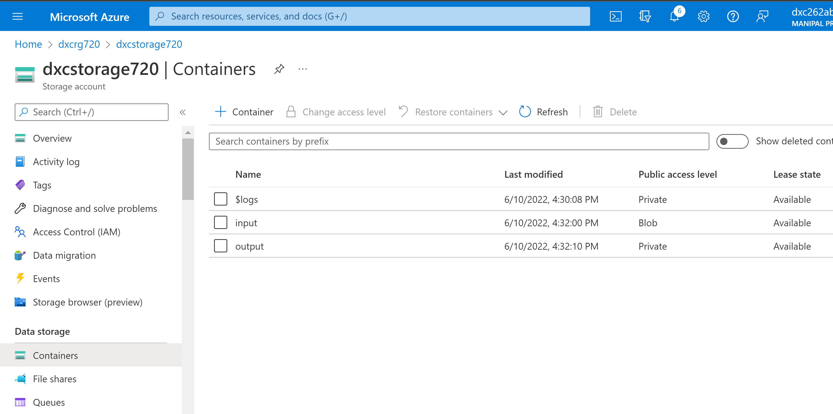

Step-3: Now upload files in input container.

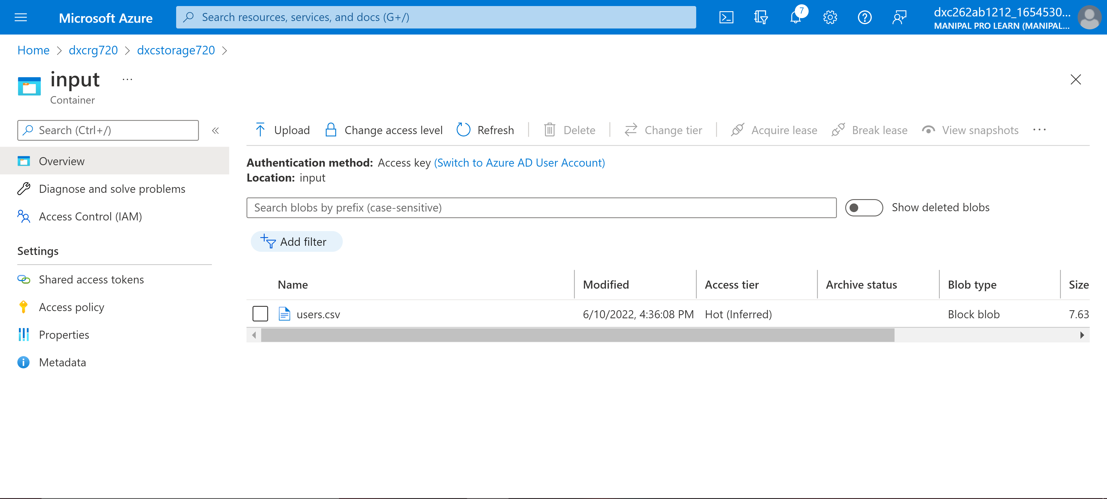

Step-4: Now open data factory storage and create a linked service.

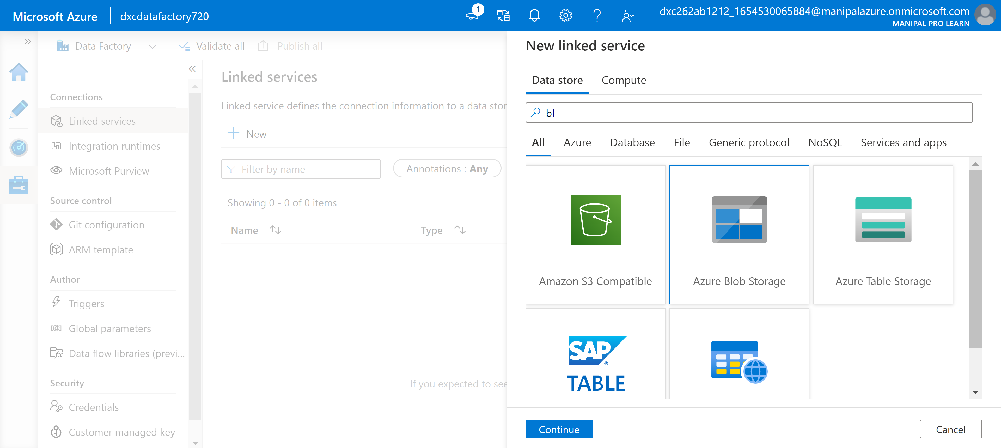

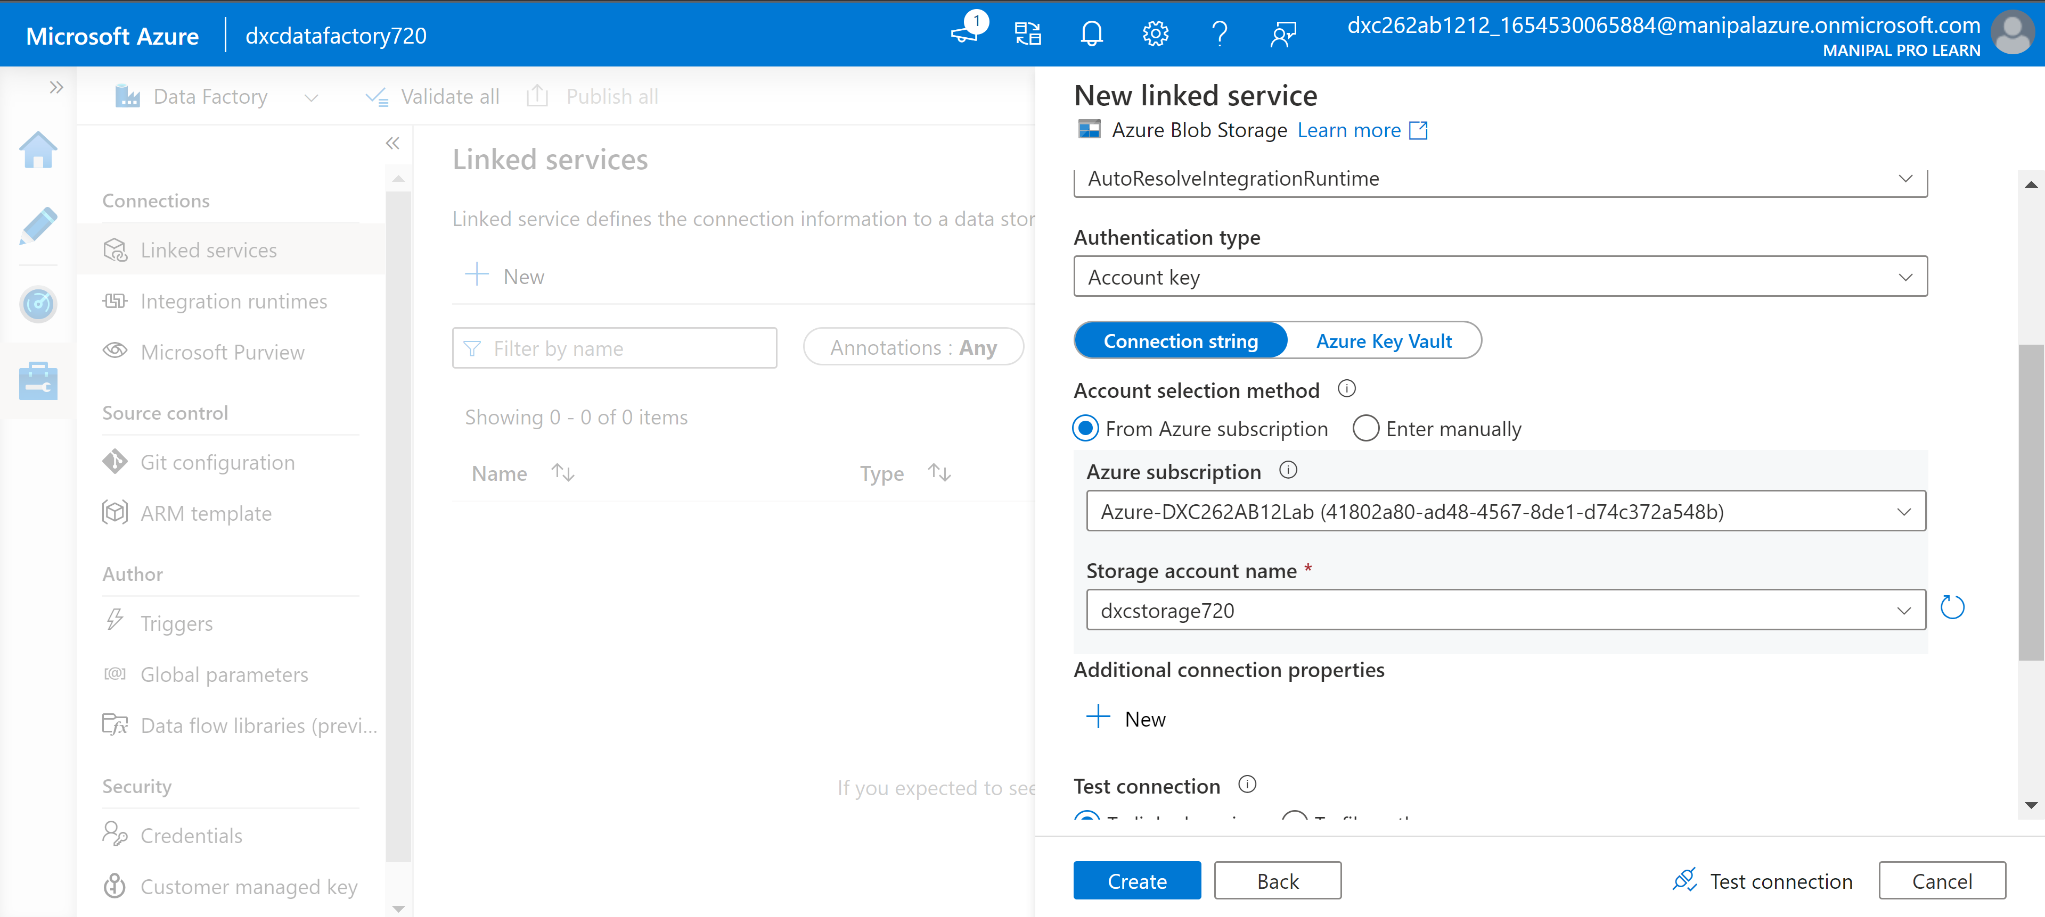

Step-5: Now create a data set named input from where data will copied and create and another data set called output where data will copied.

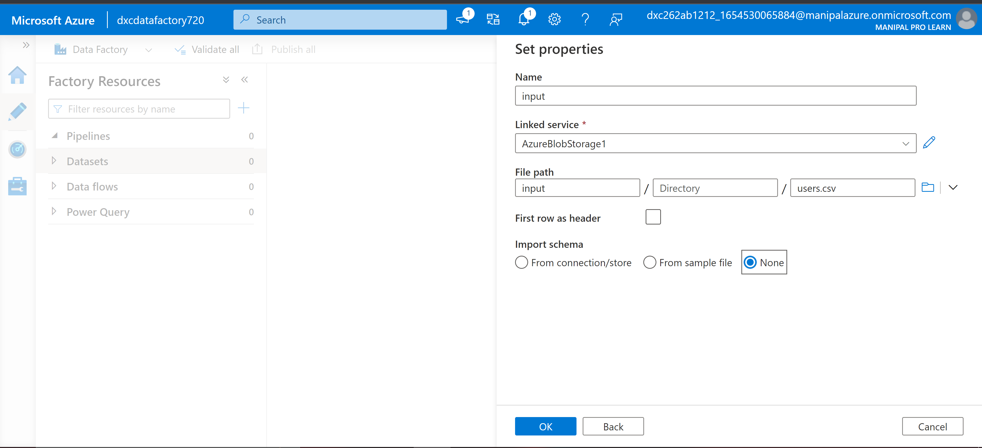

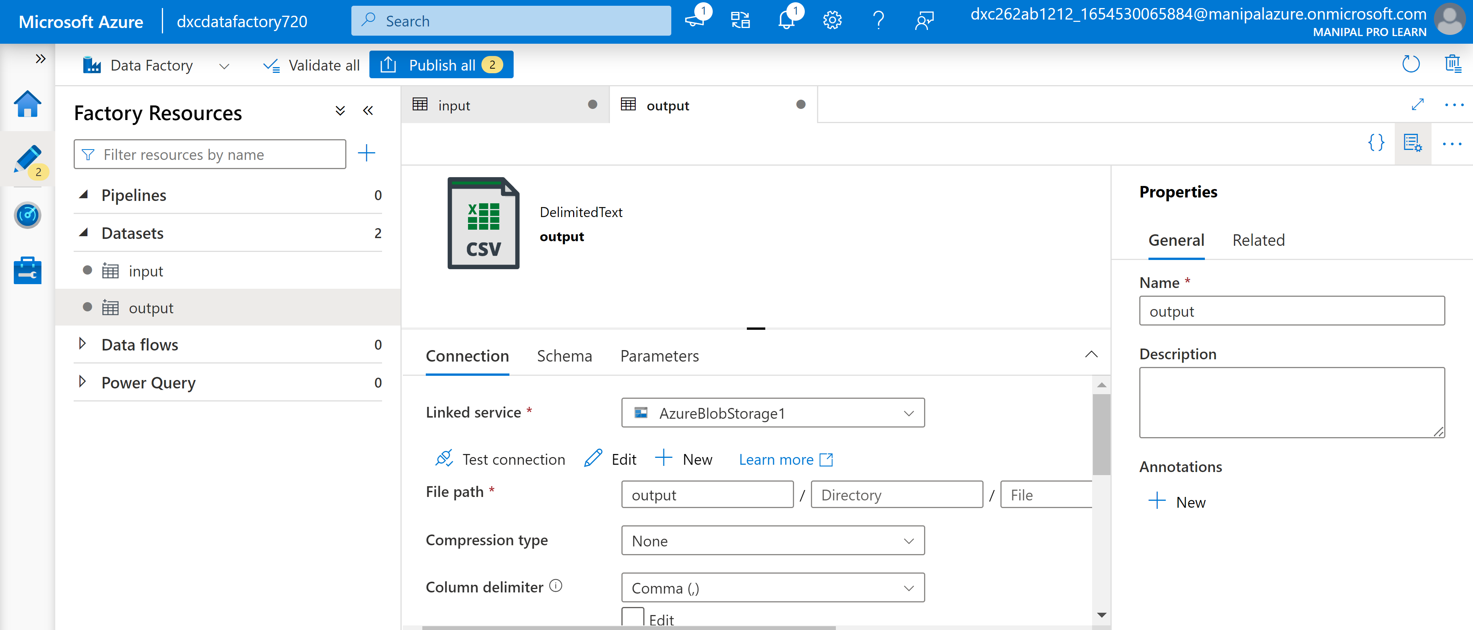

Step-6: Now we need to create a pipeline where we will be copying data and click on publish all to publish them.

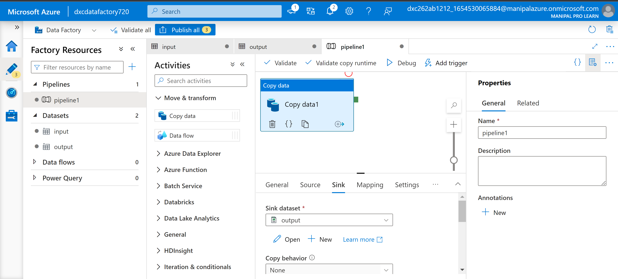

Step-7: To add triggers click on add triggers and select New/Edit.

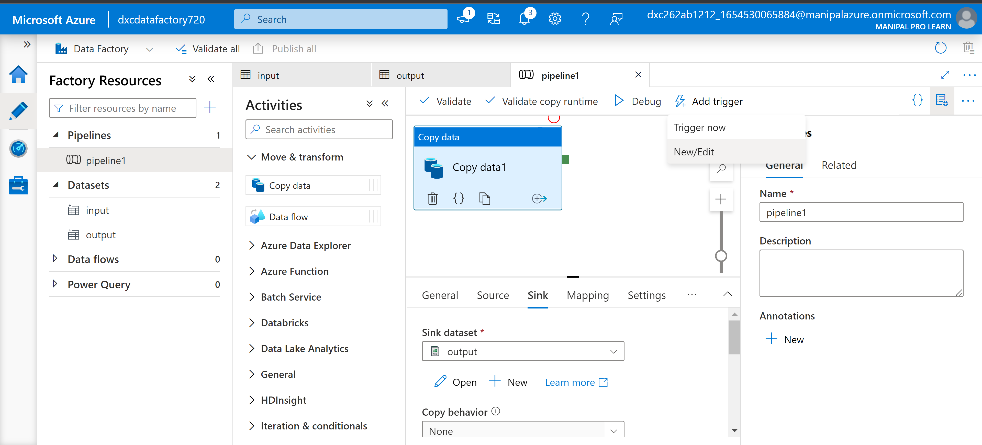

Step-8: now create Triggers based on requirement.

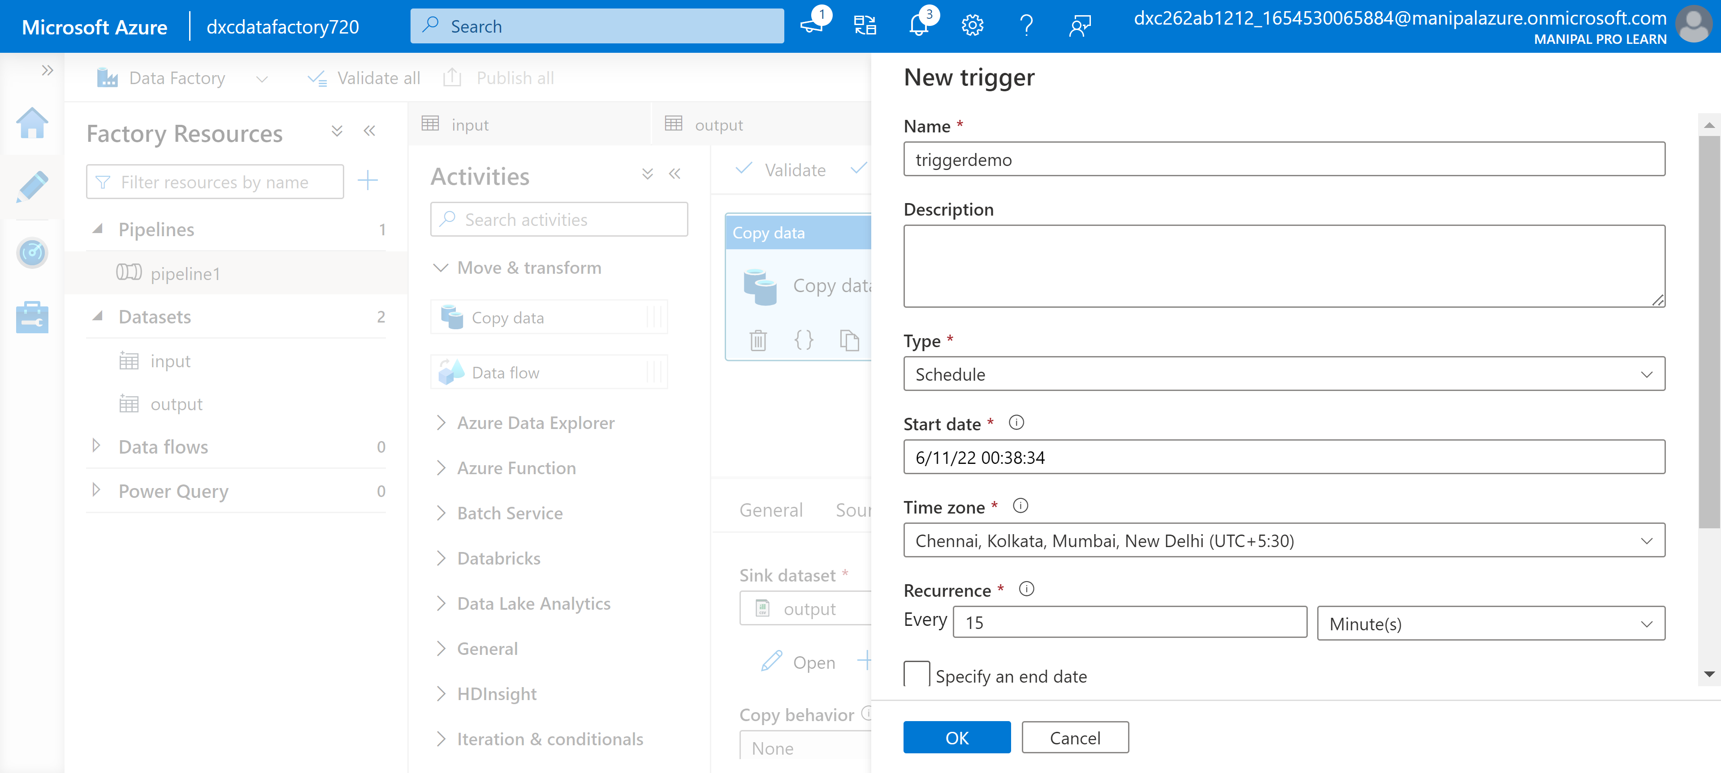

Step-9: Finally click on publish to make triggers active.

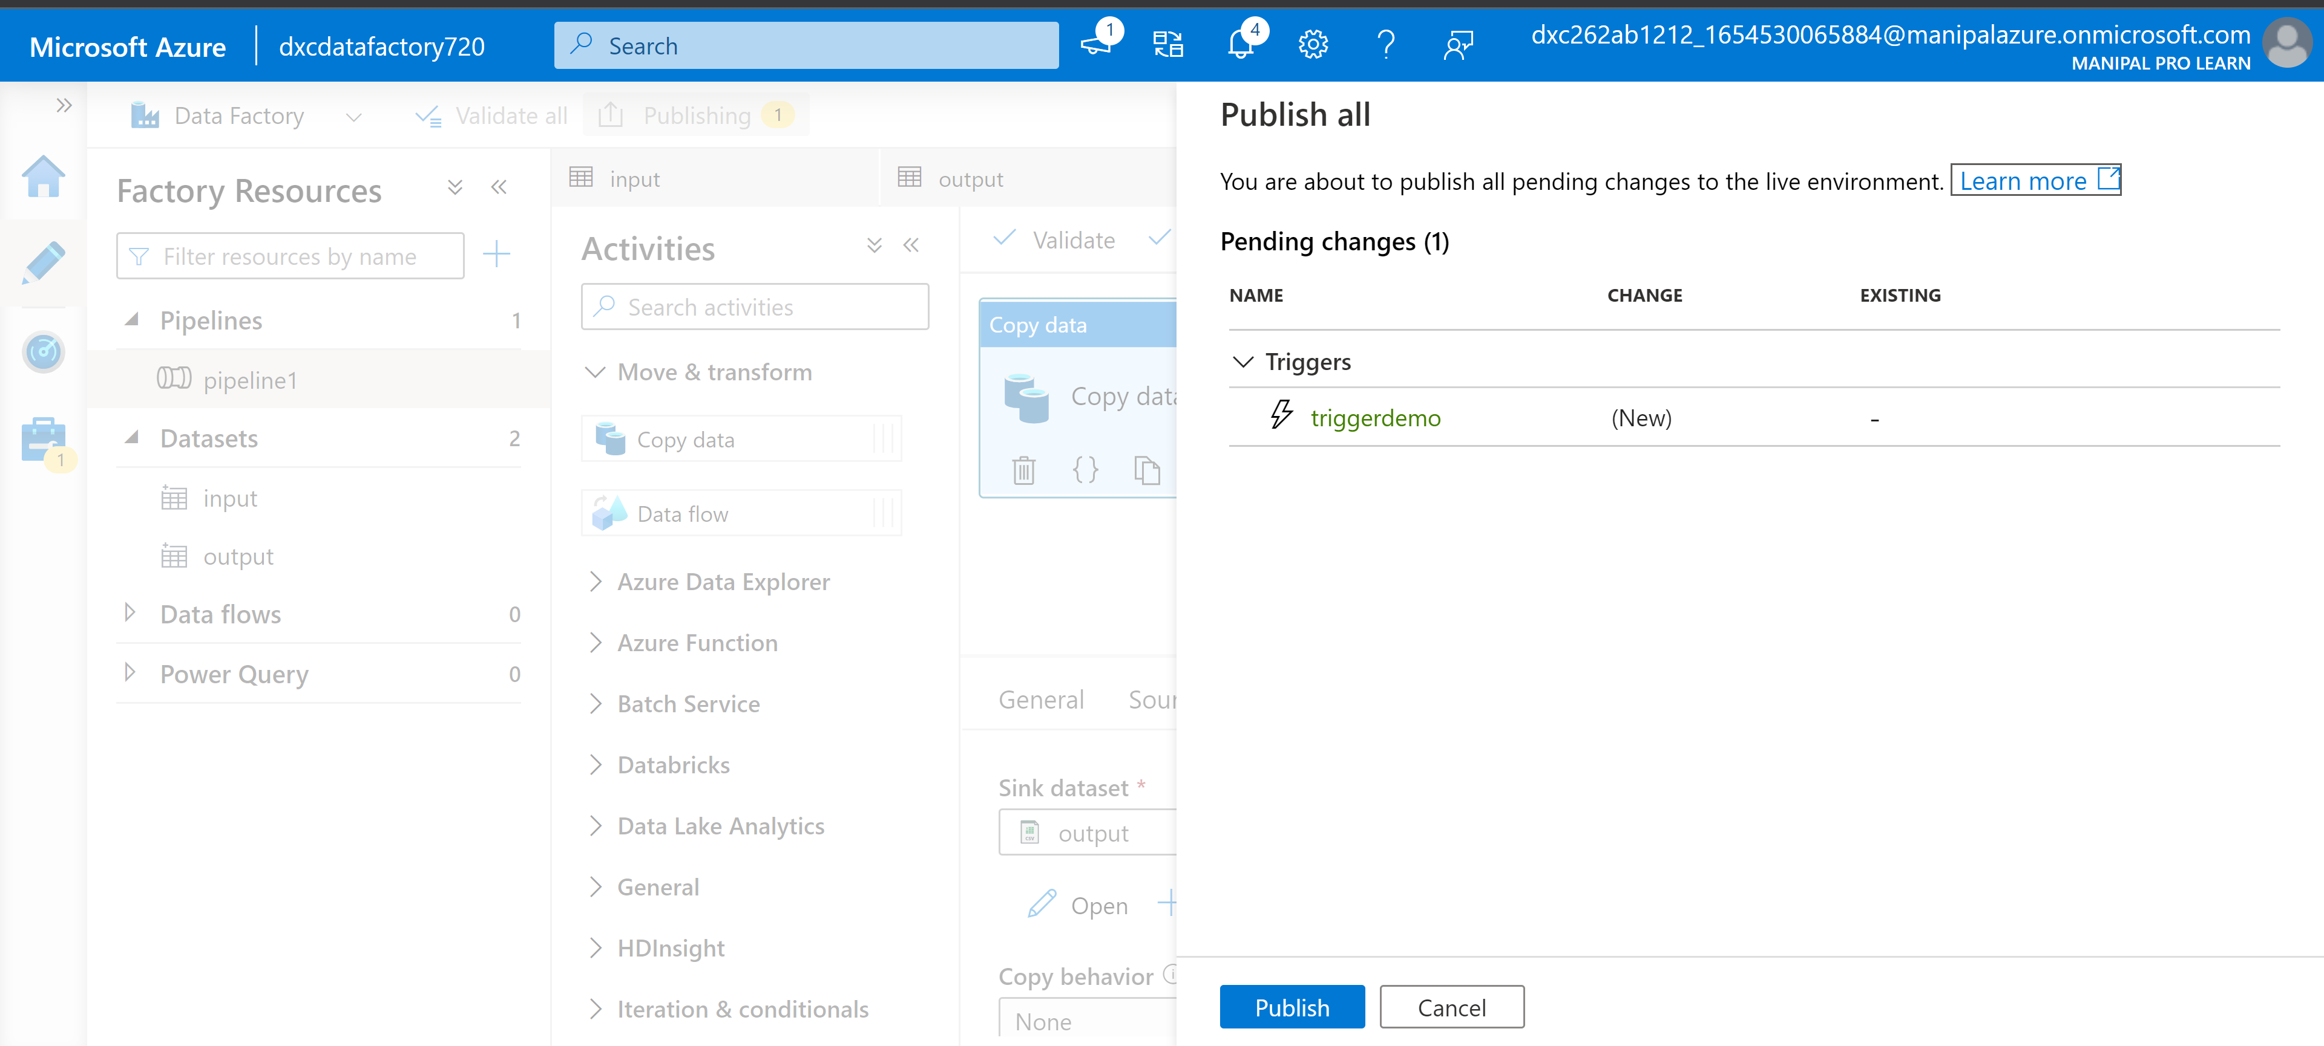

Practical Lab: Create Azure **SQL Server and Database**

Step-1: click on sql databases on main menu.

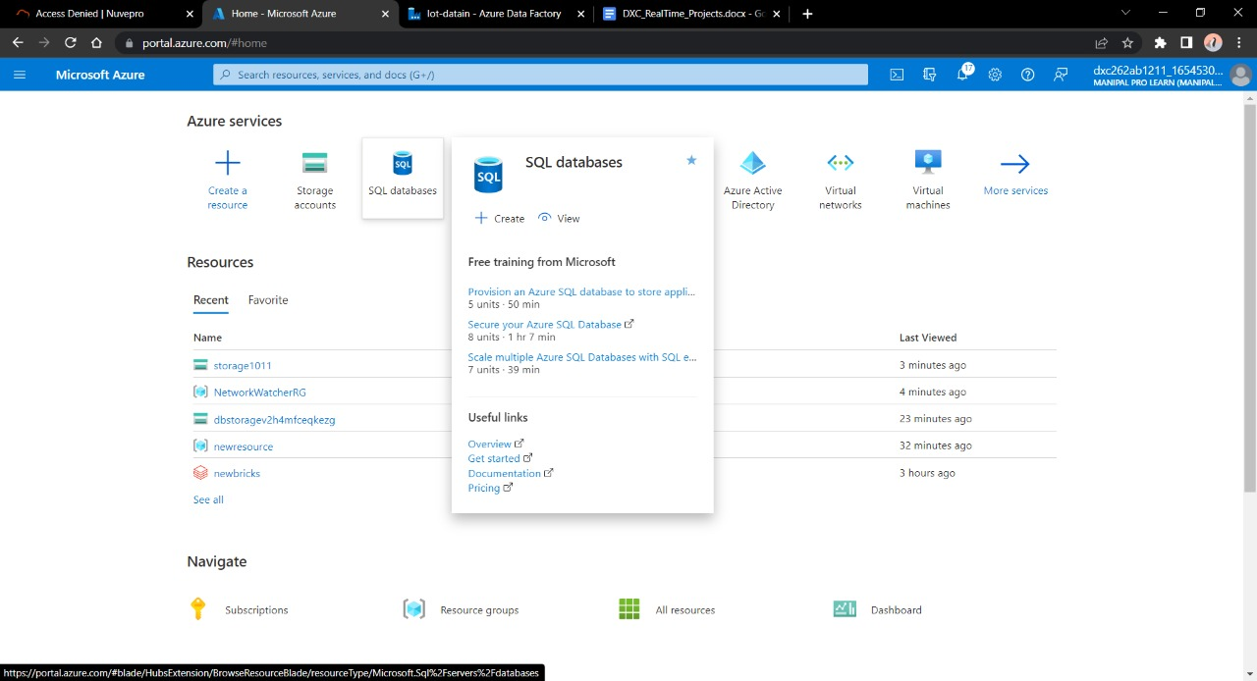

Step-2: here give database a name and click on create new to create a server.

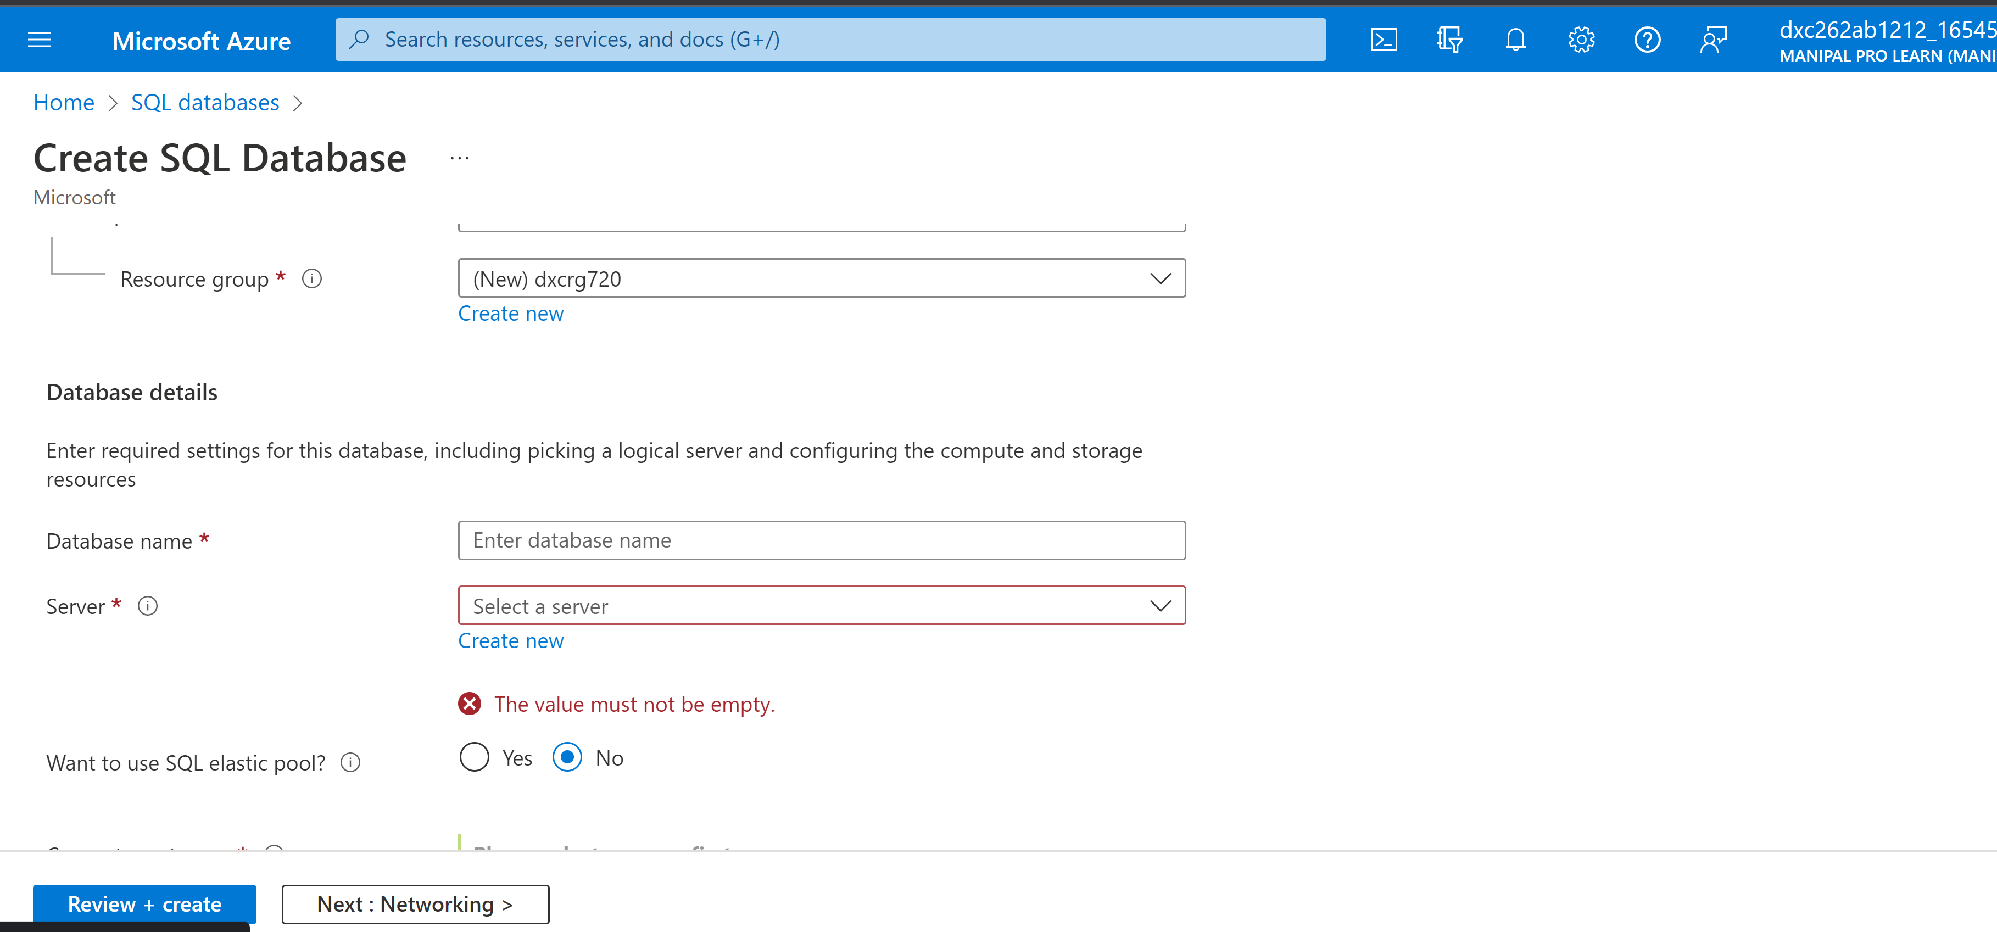

Step-3: Now give required information and click on to create a database server.

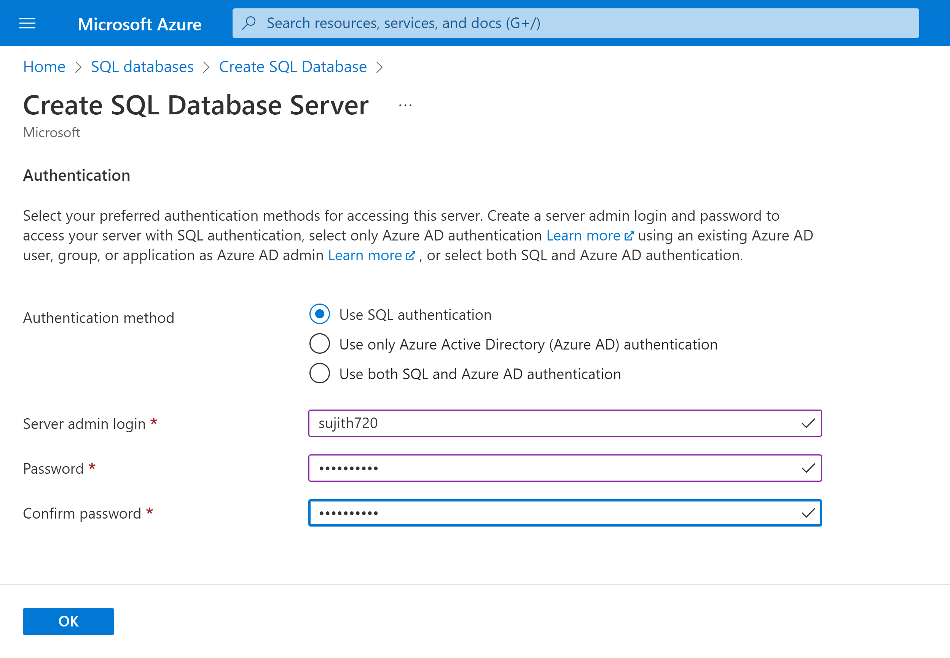

Step-4: Now click on Reiew+create to create new sql database.

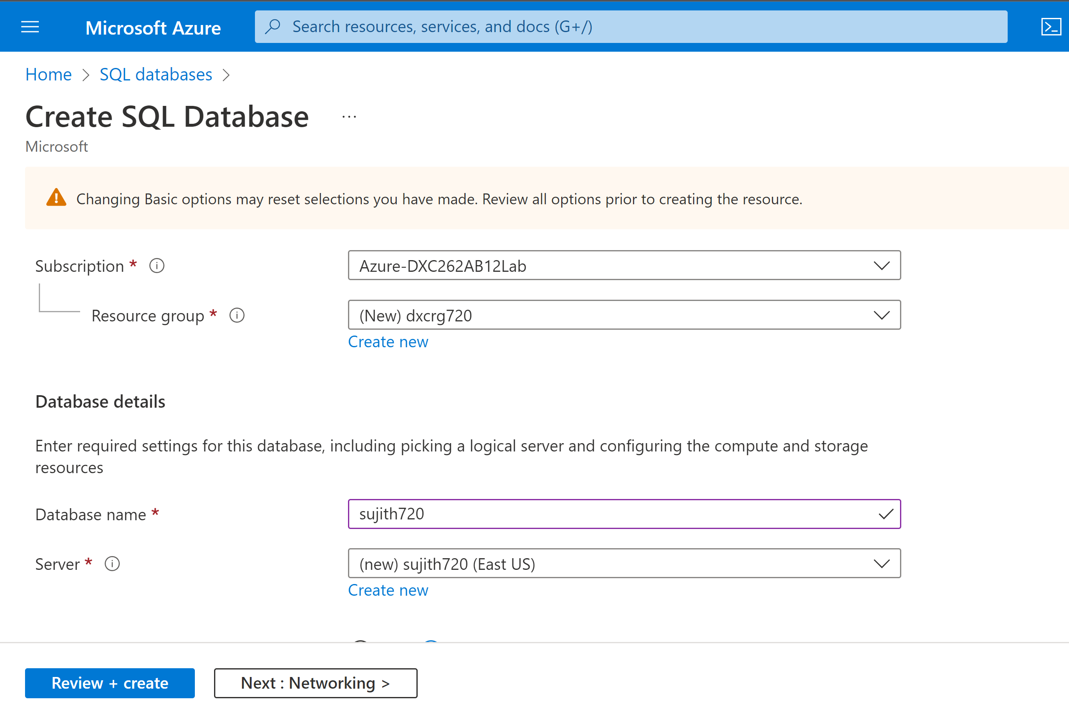

Practical Lab: Add another pipelines for moving data from Staging to **SQL DB**

Step-1: select datafactories and open data factory studio and Click on ingest and click on next .

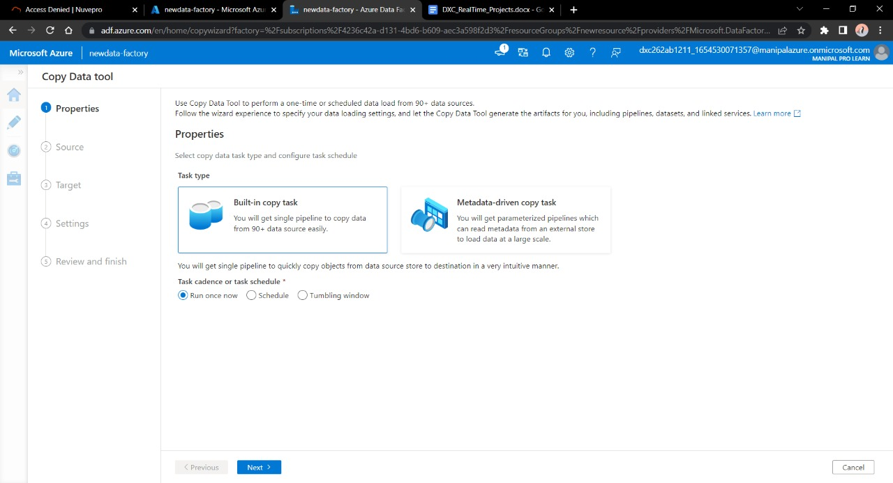

Step-2: now select Azure blob storage and create new link service.

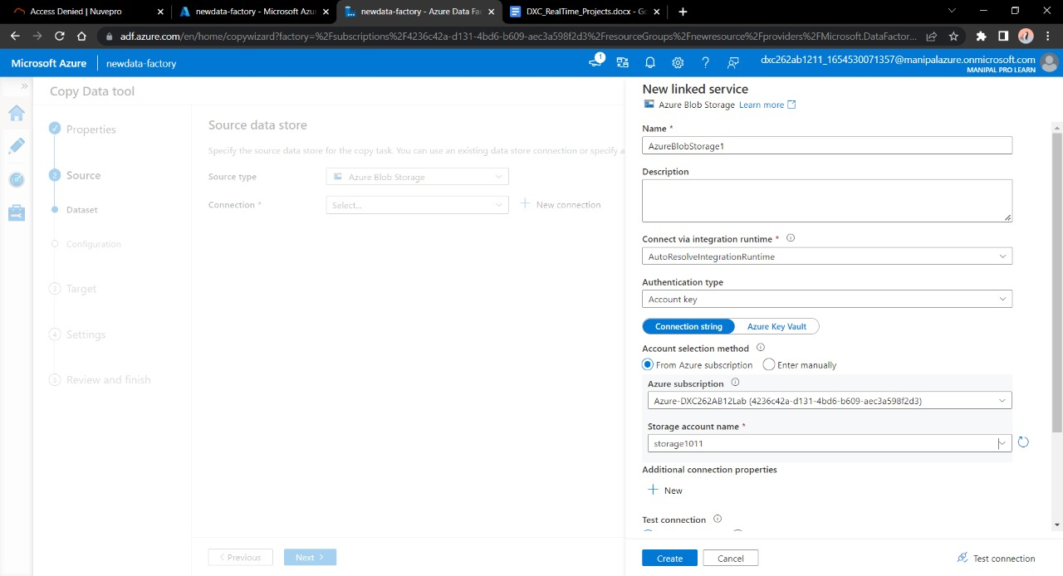

Step-3: now select the folder from where data has to been copied.

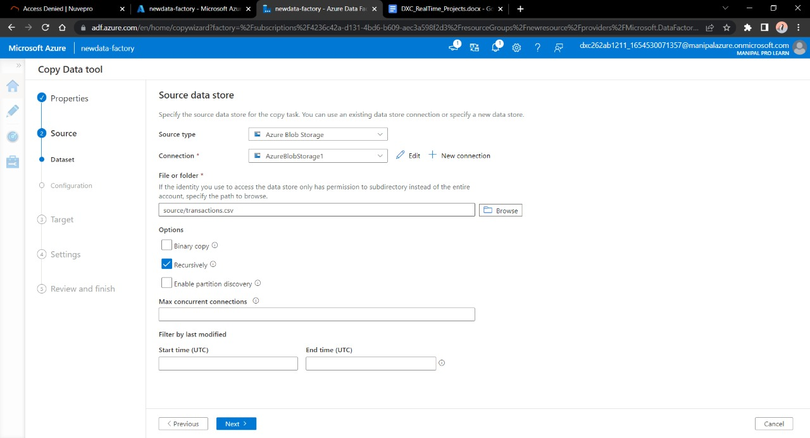

Step-4: Now in destination select azure sqldatabase and create connection.

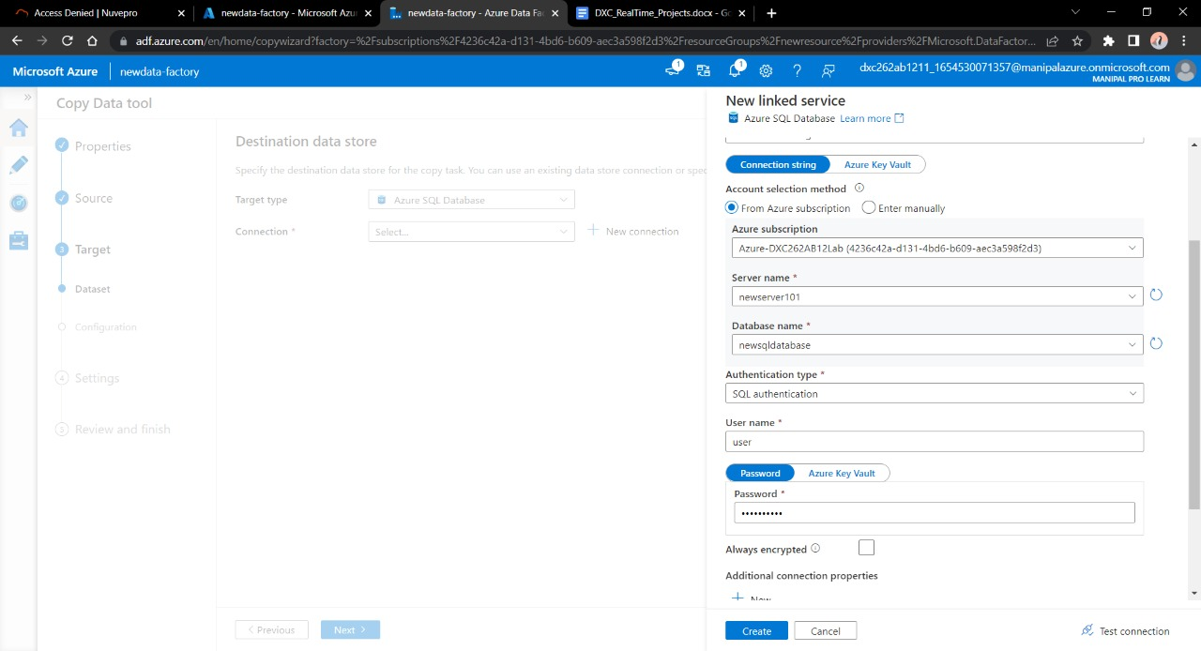

Step-5: now give name to the file copied and ensure data , connection

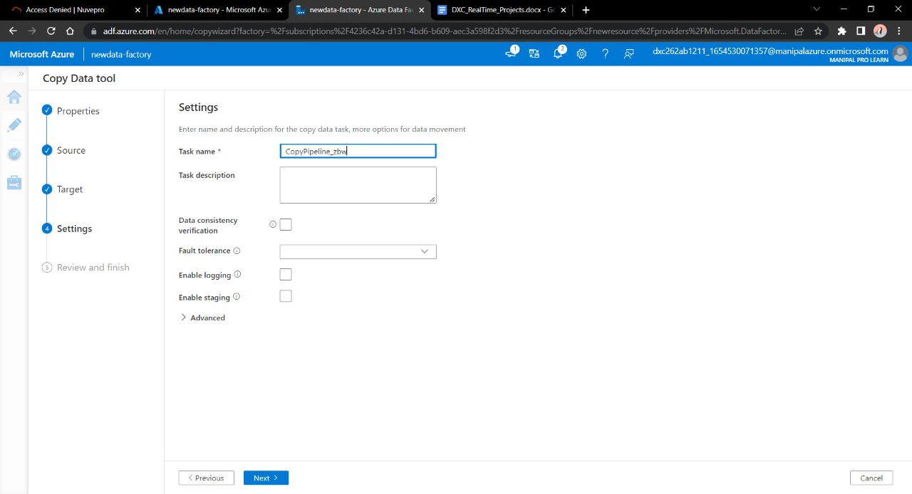

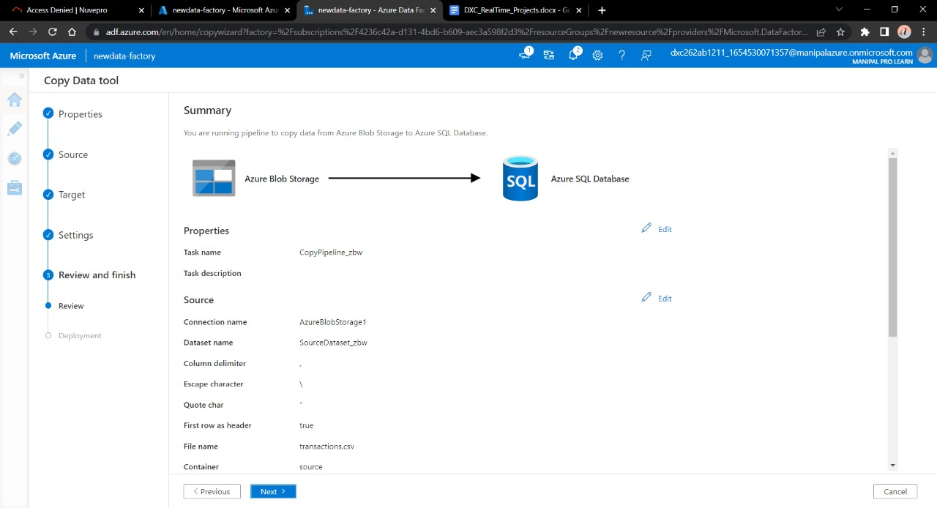

Step-6: Now we need trigger the pipeline and goto monitor to vitness the runs,

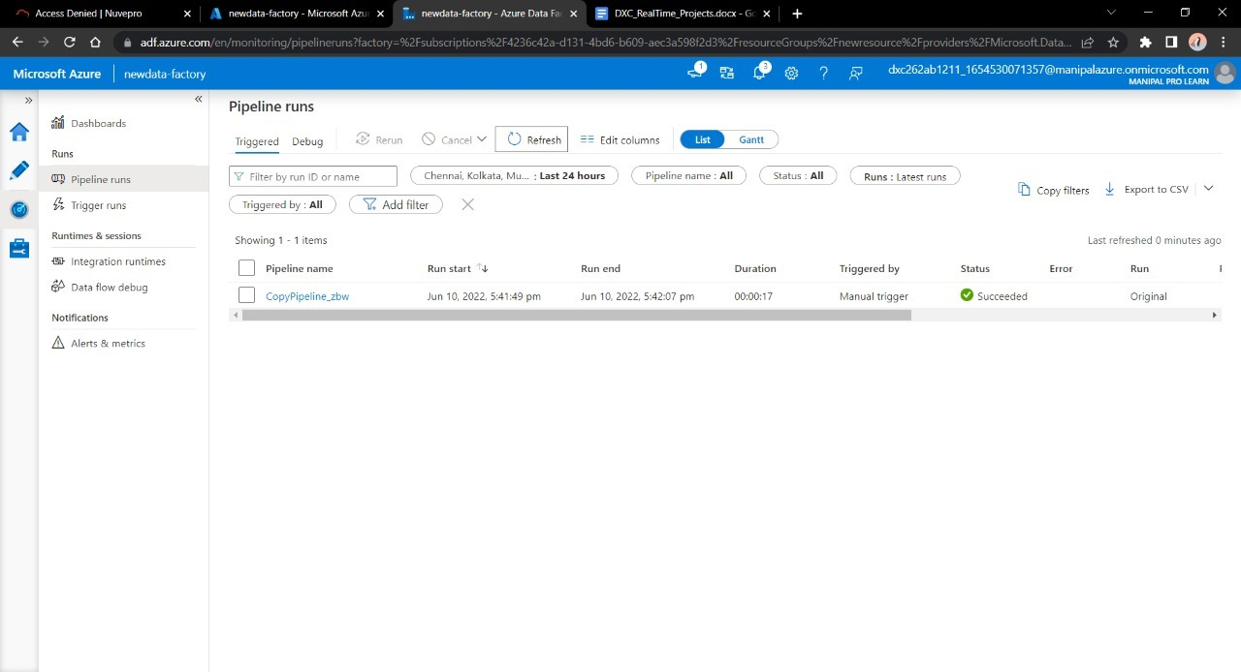

Step-7:Now Goto sql database to check whether the data is copied or not.

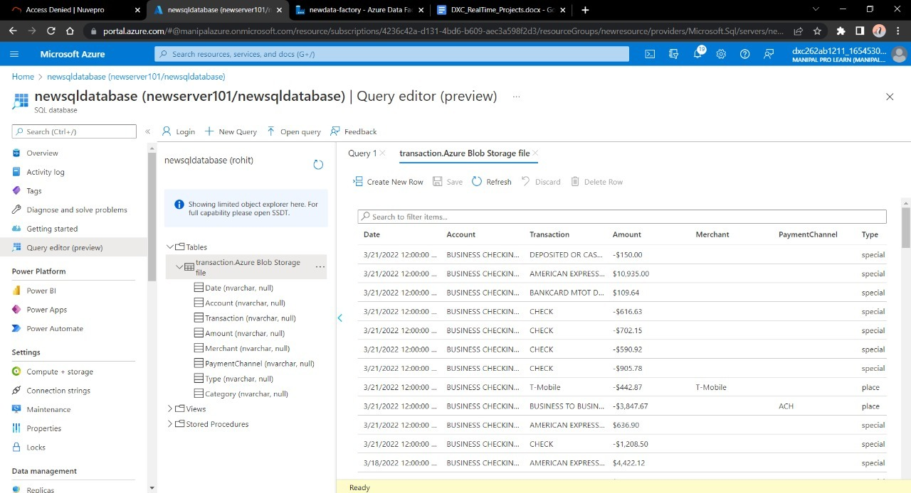

**Result:**

We are creating a pipeline in data factories to copy data from a blob container to sql database.

**Conclusion:**

We are suceesfully storing the stagging data in sql database.

**References:**

* Microsoft technical documentation.

Name: Thopucherla Sujith No

Reg No: DXC262AB12010

**Project2 Name: AP Morgan Data Platform**

Date: 10-06-2022

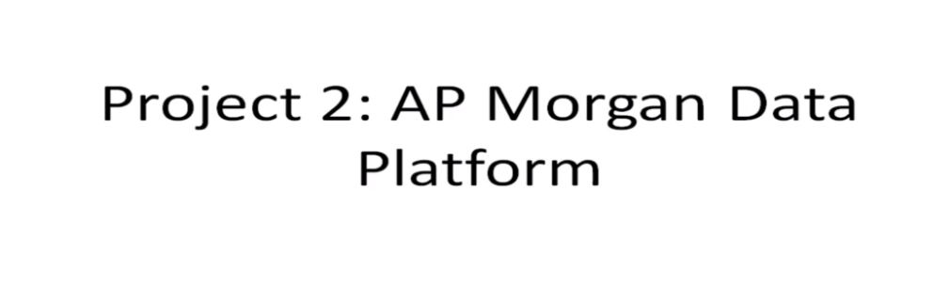

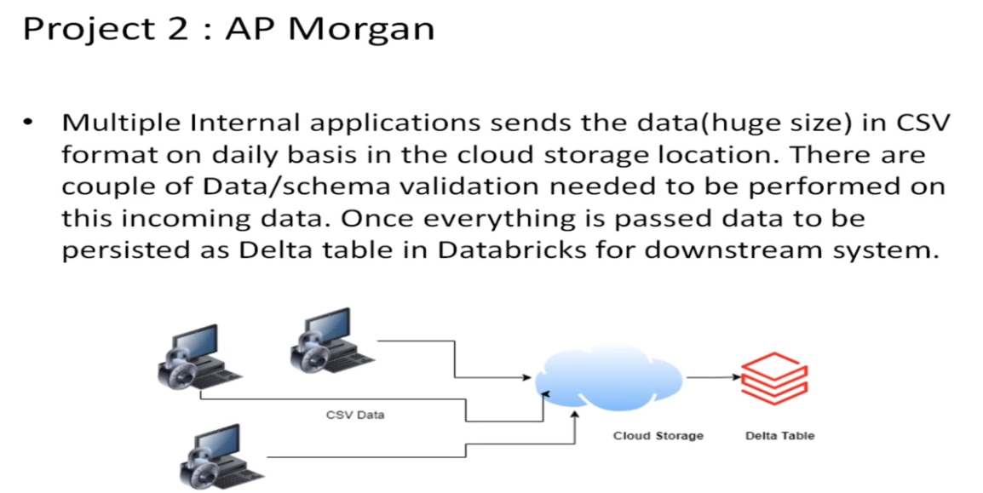

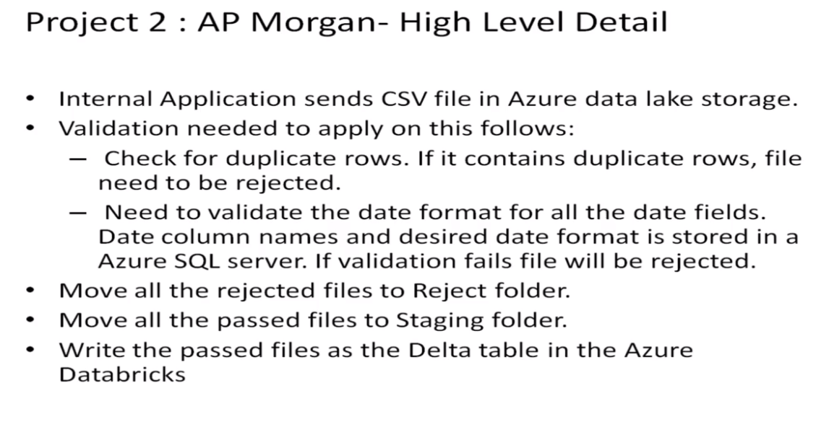

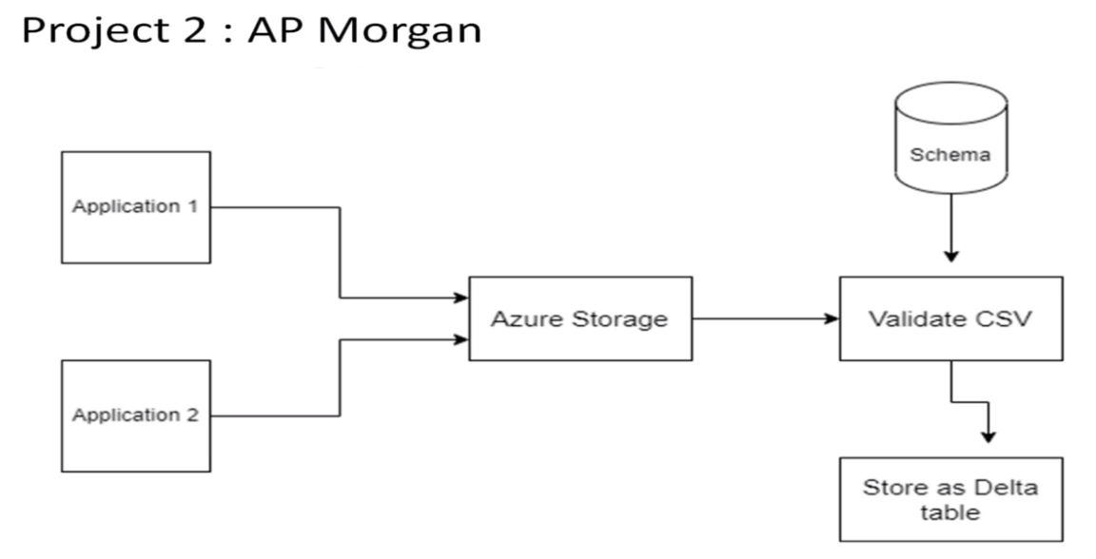

Practical Lab: Create a **Databricks**

Step-1: Open Azure portal and search for databricks and select it and click on create to create new databricks.

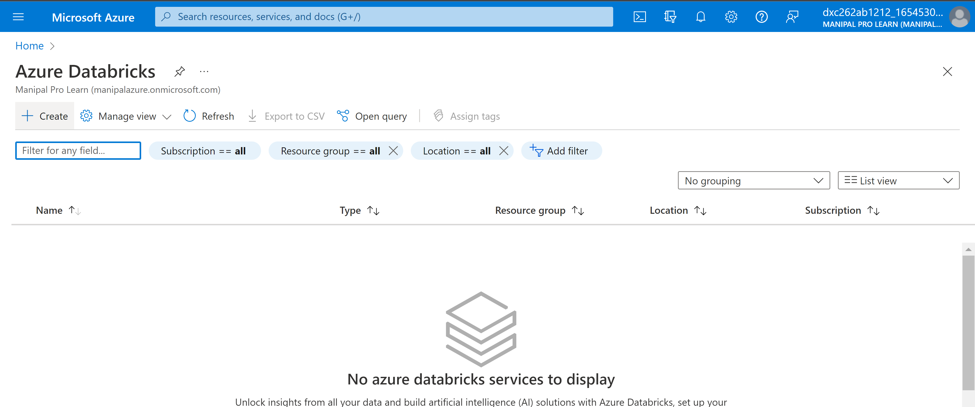

Step-2: Now give required information and Click on Review+create .

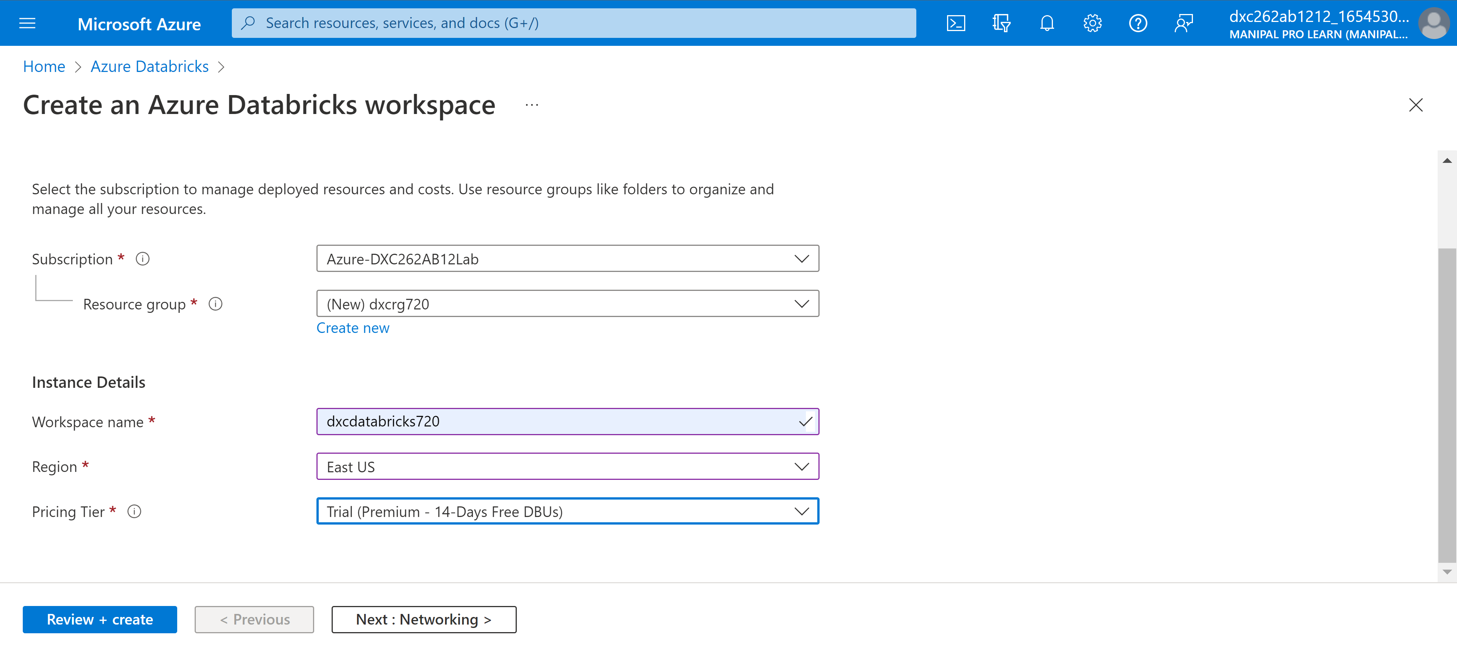

Step-3: After Sucessful deployment Goto resources.

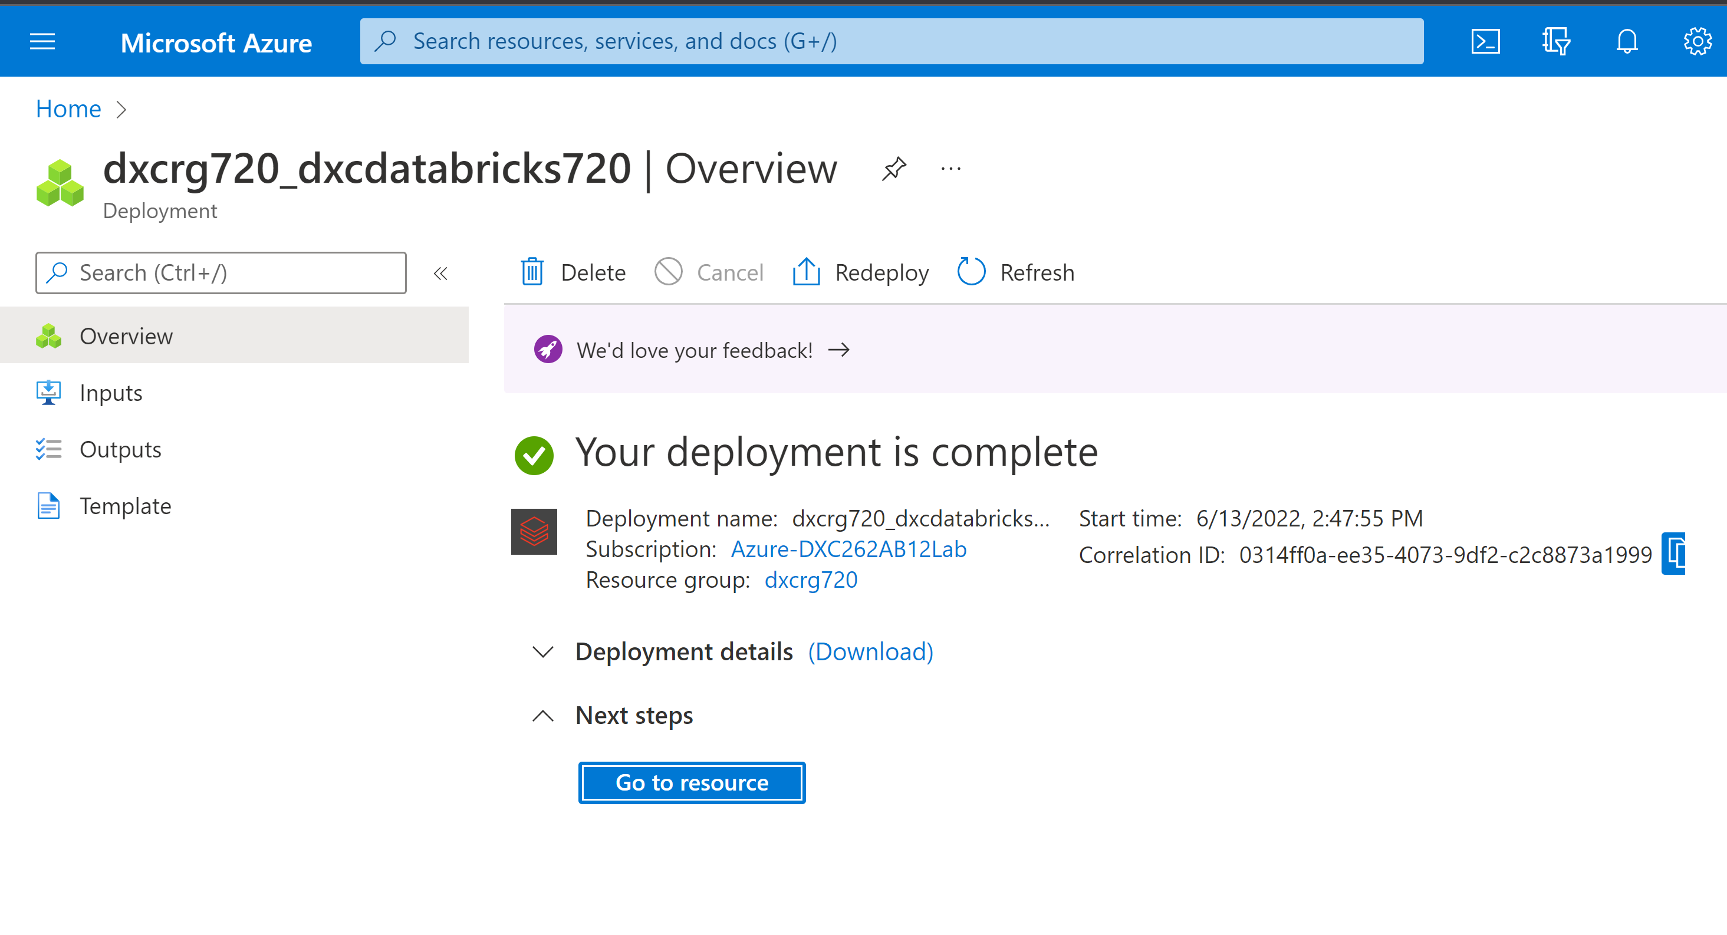

Step-4: Now launch data bricks workspace.

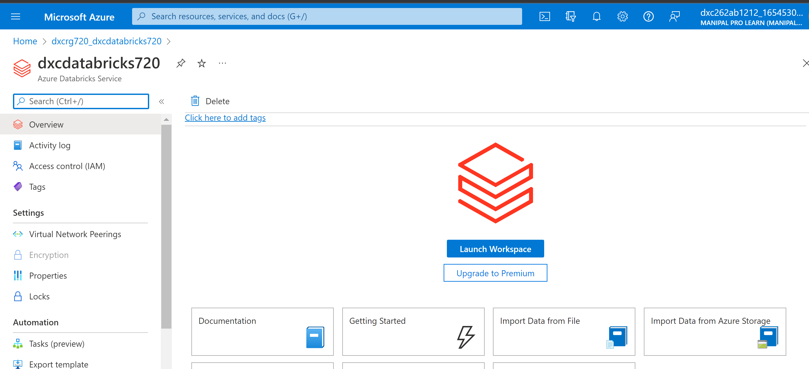

Practical Lab: Create **Cluster in Azure Databricks**

Step-1: Goto compute and Click on create cluster.

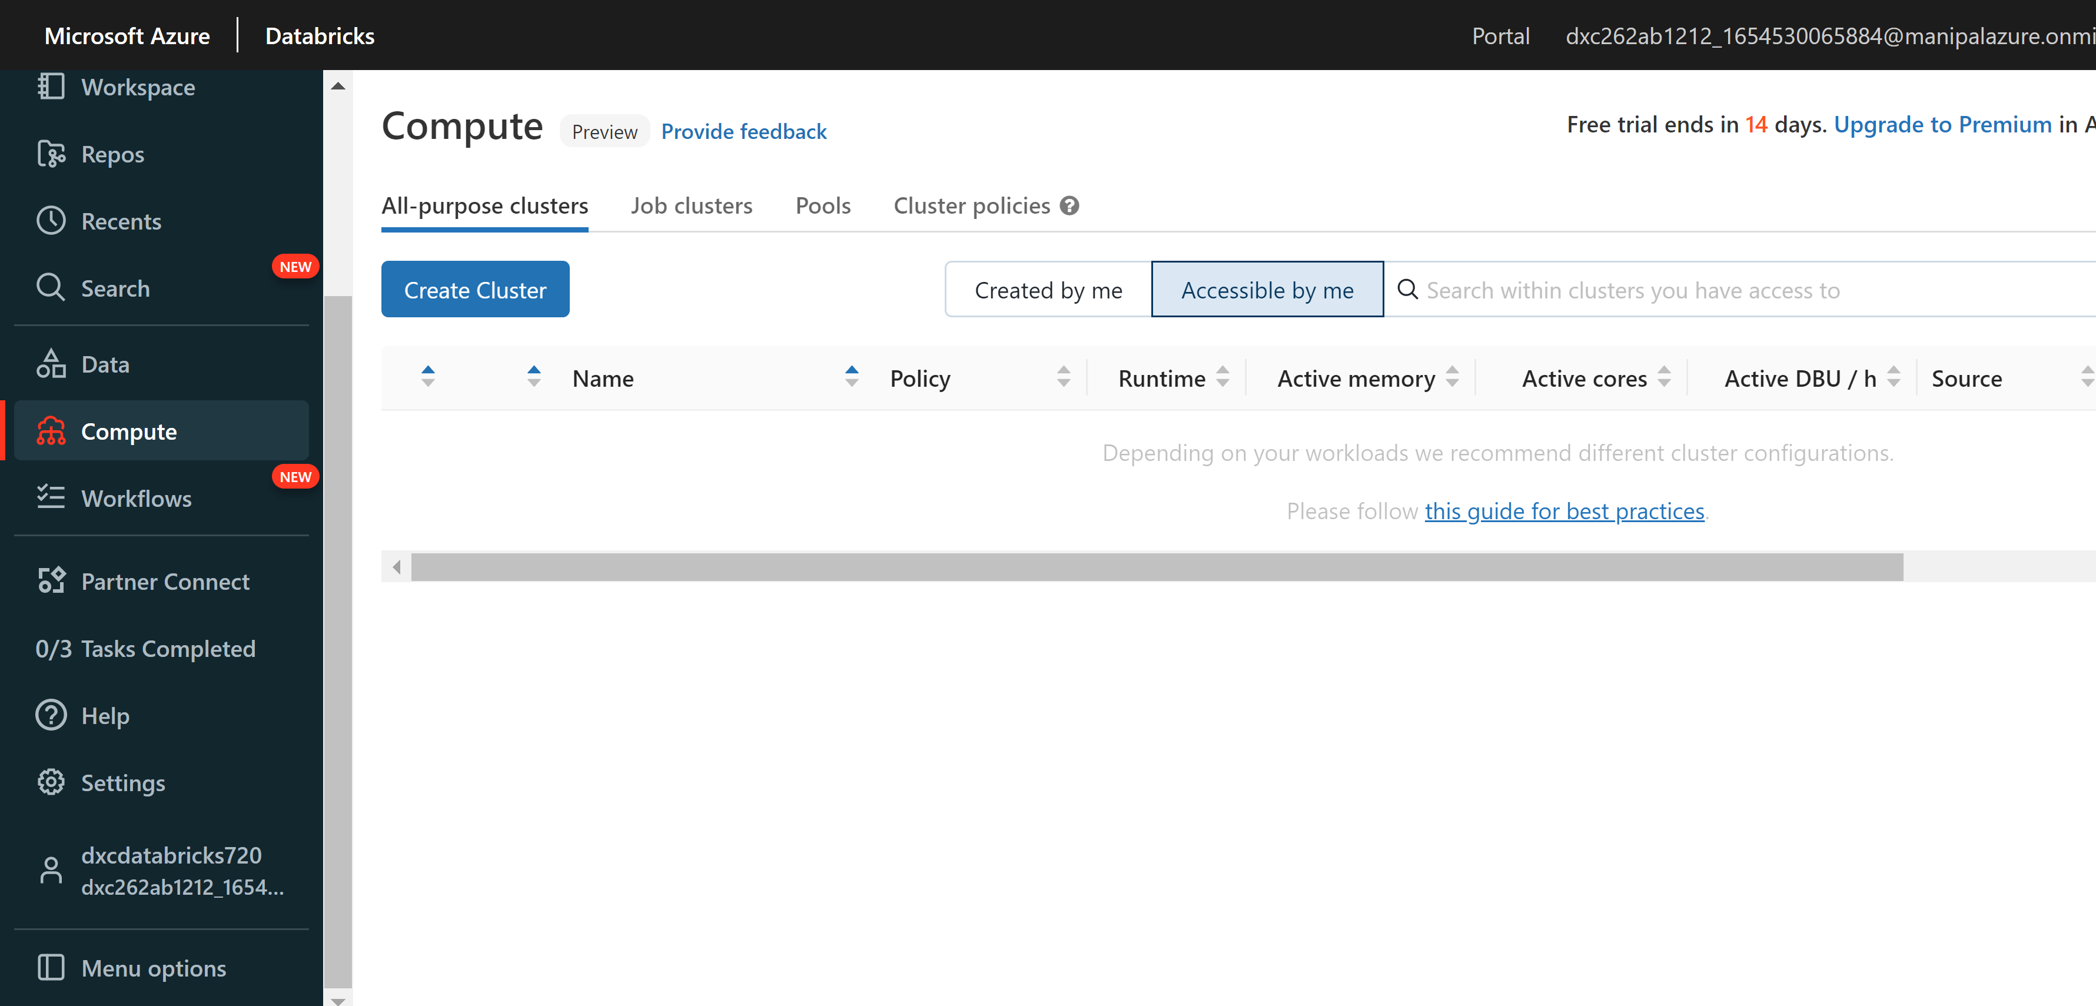

Srep-2: Now give required information and click on create cluster.

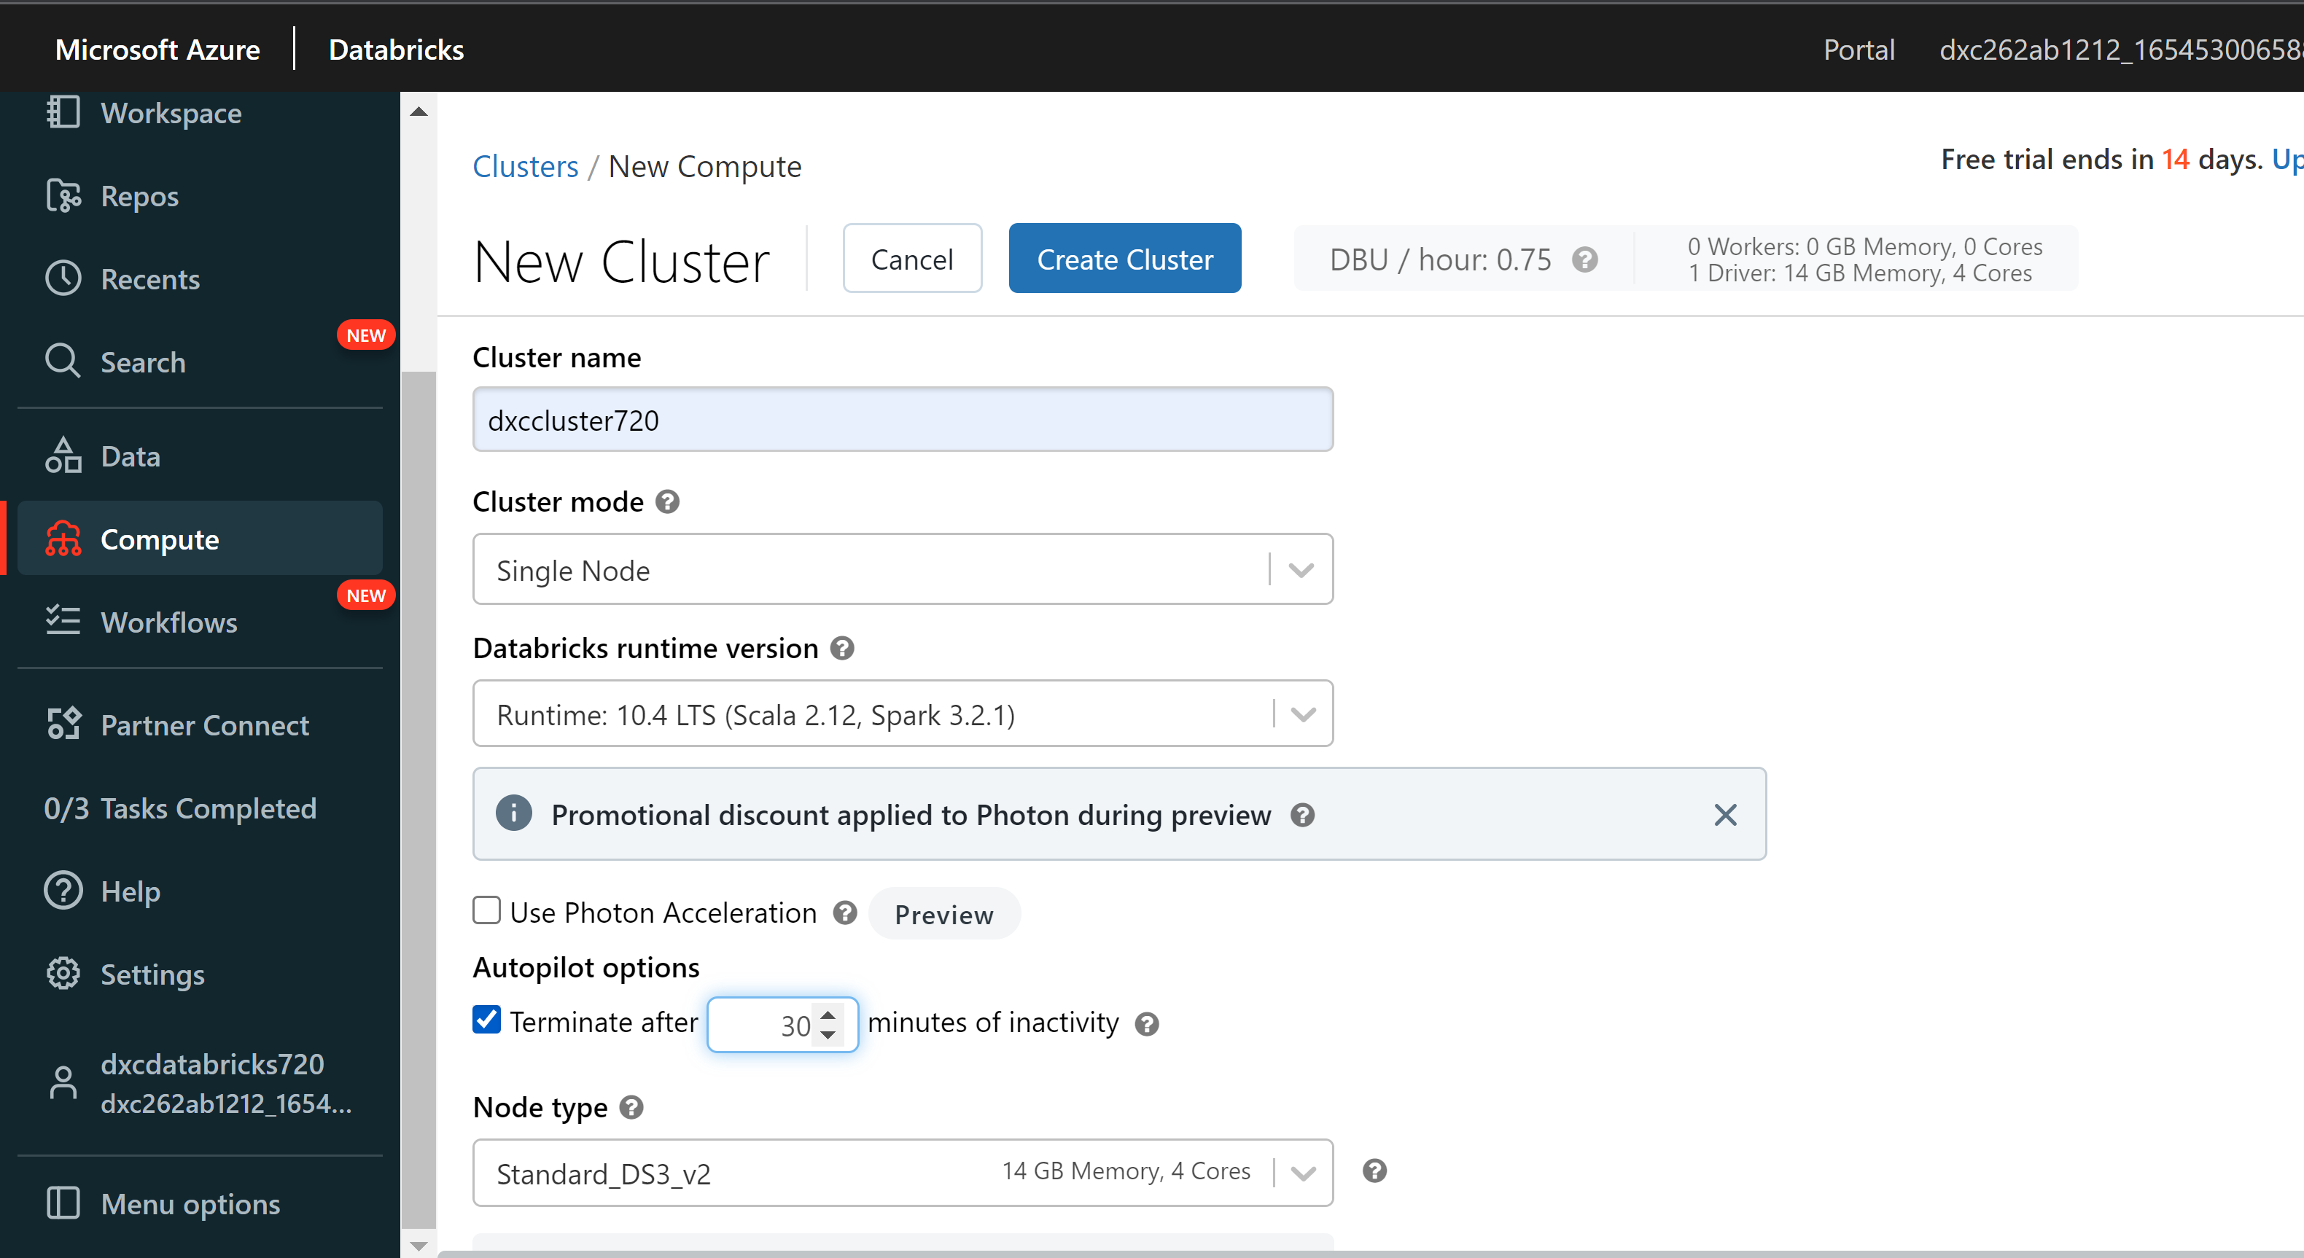

Practical Lab: **Add notebook in Databricks** and Implement the Business Logic

Step-1: Goto to workspace and click on create and click on Notebook.

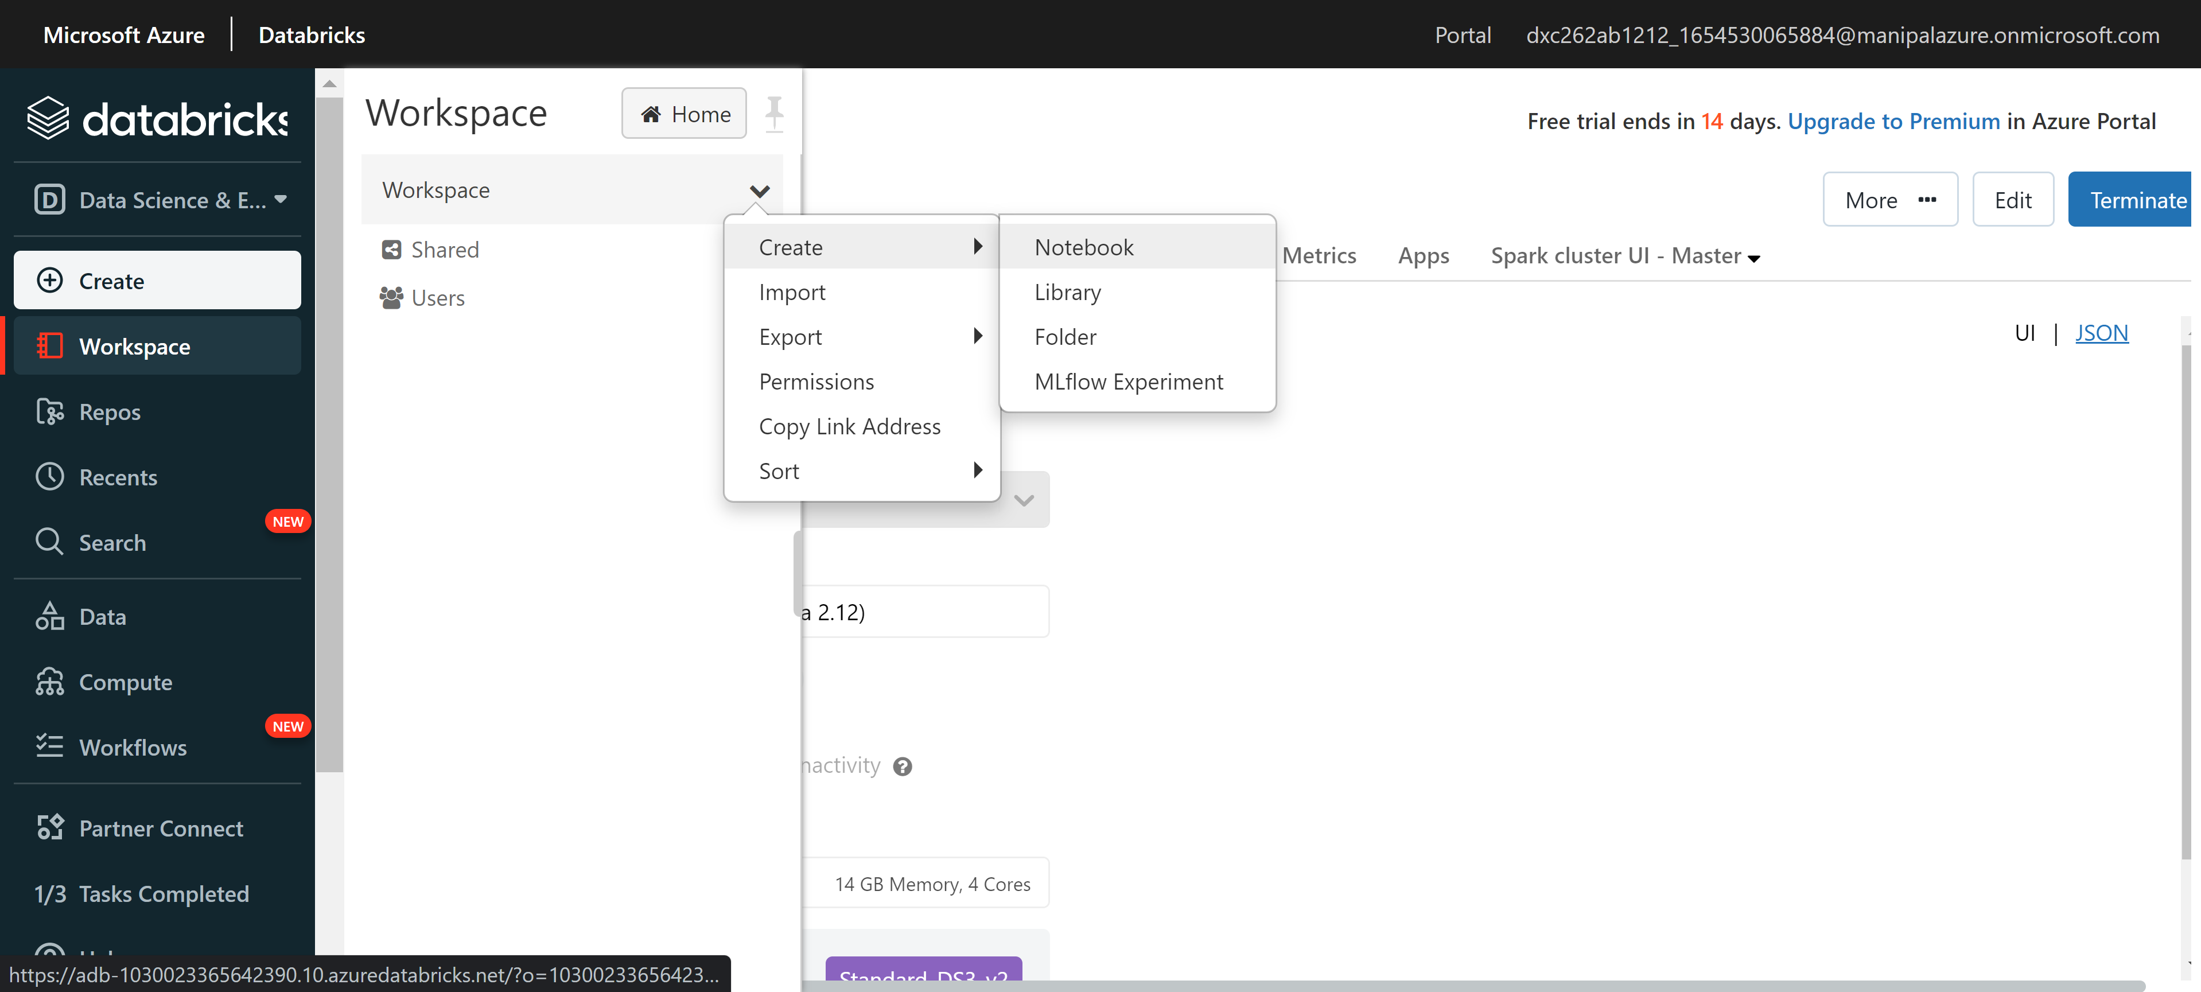

Step-2: give name to notebook Select language and cluster and click on create.

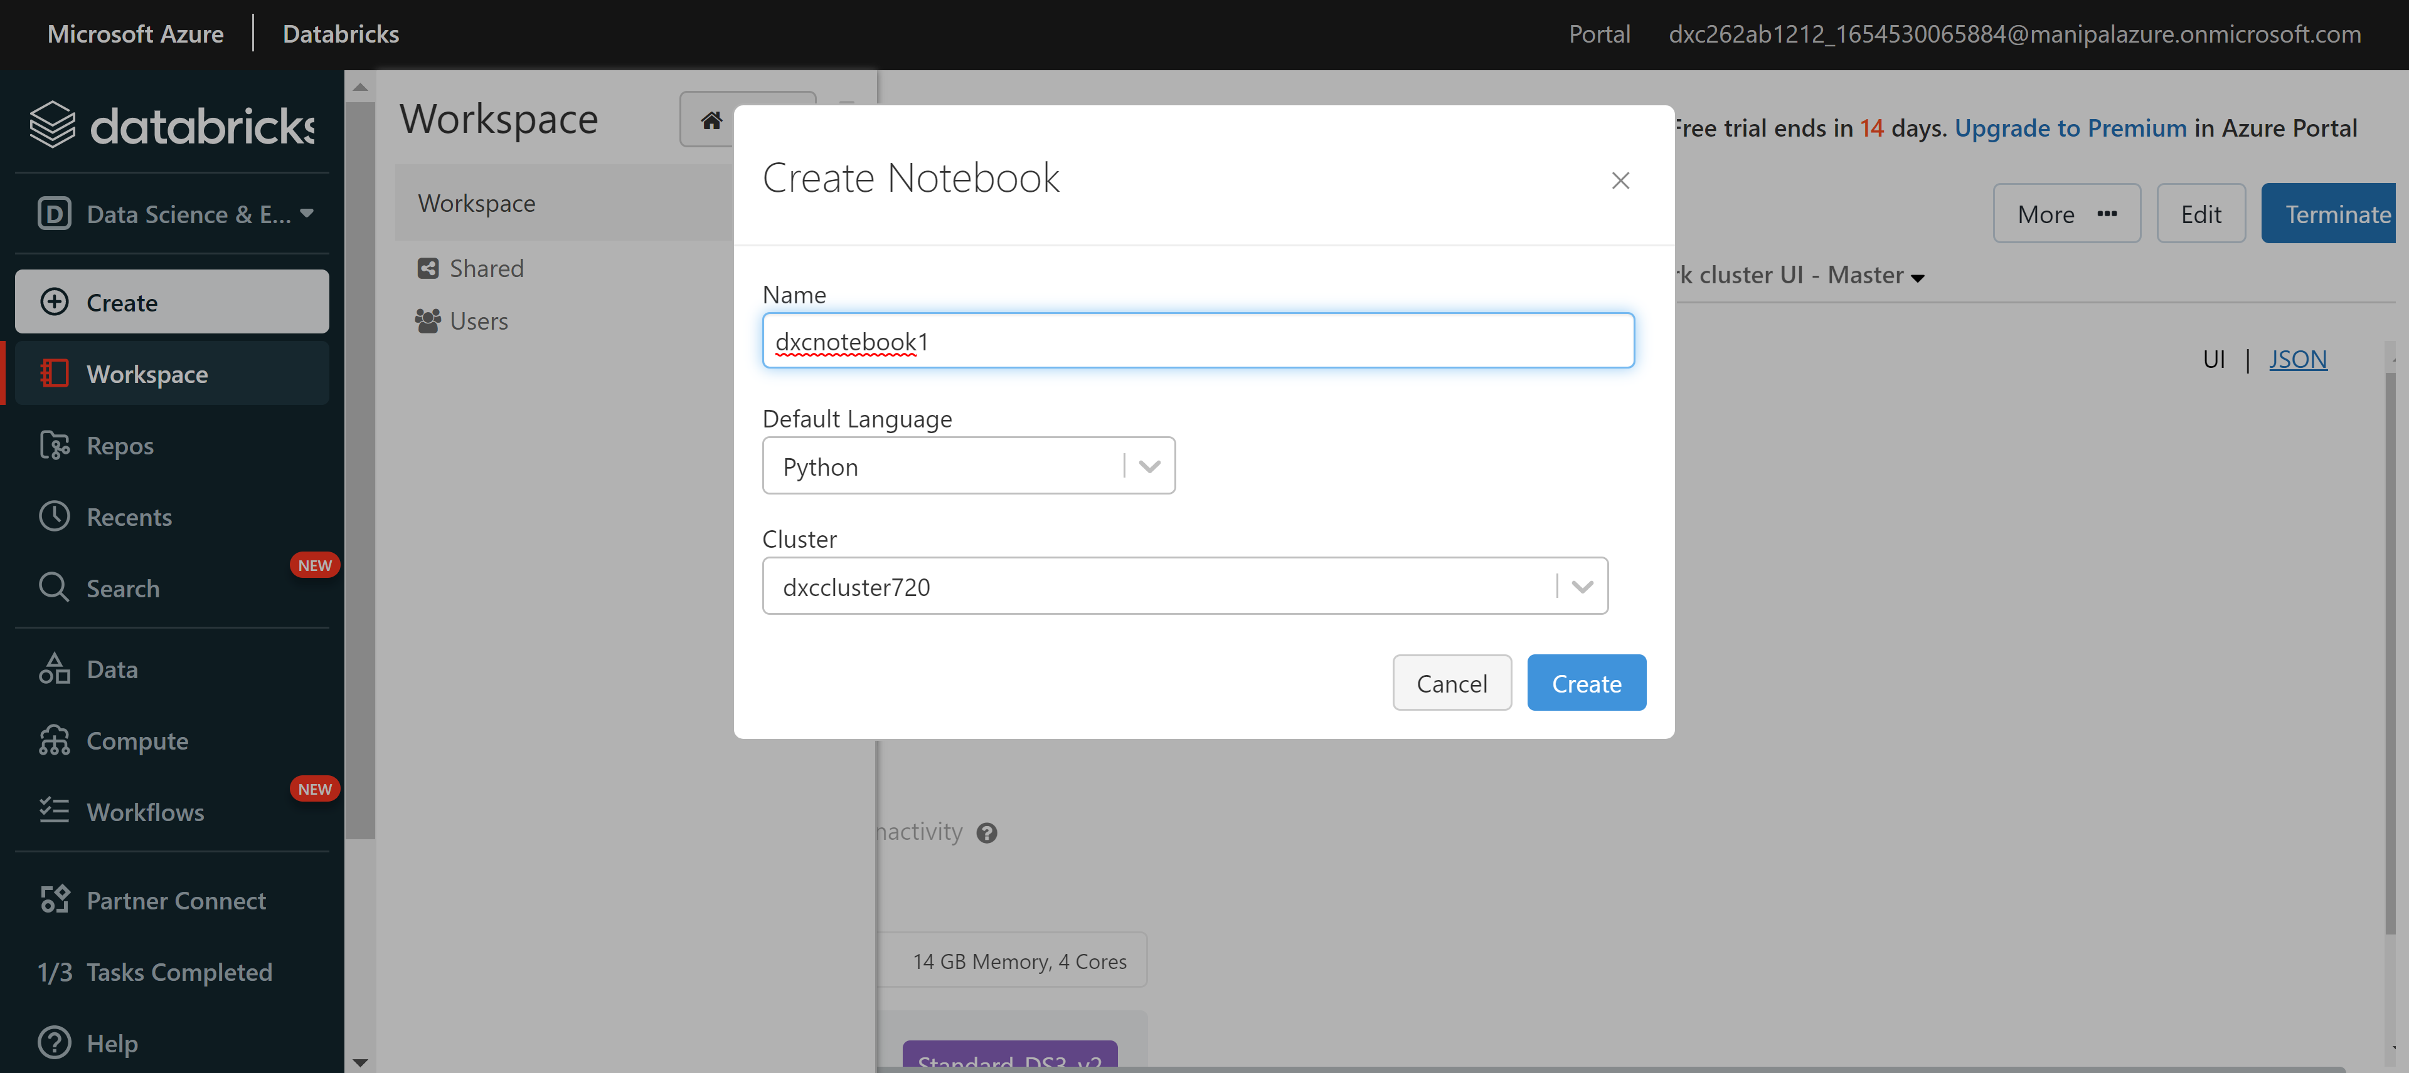

Step-3: now build the logic and click on run cells to execute

the logic.

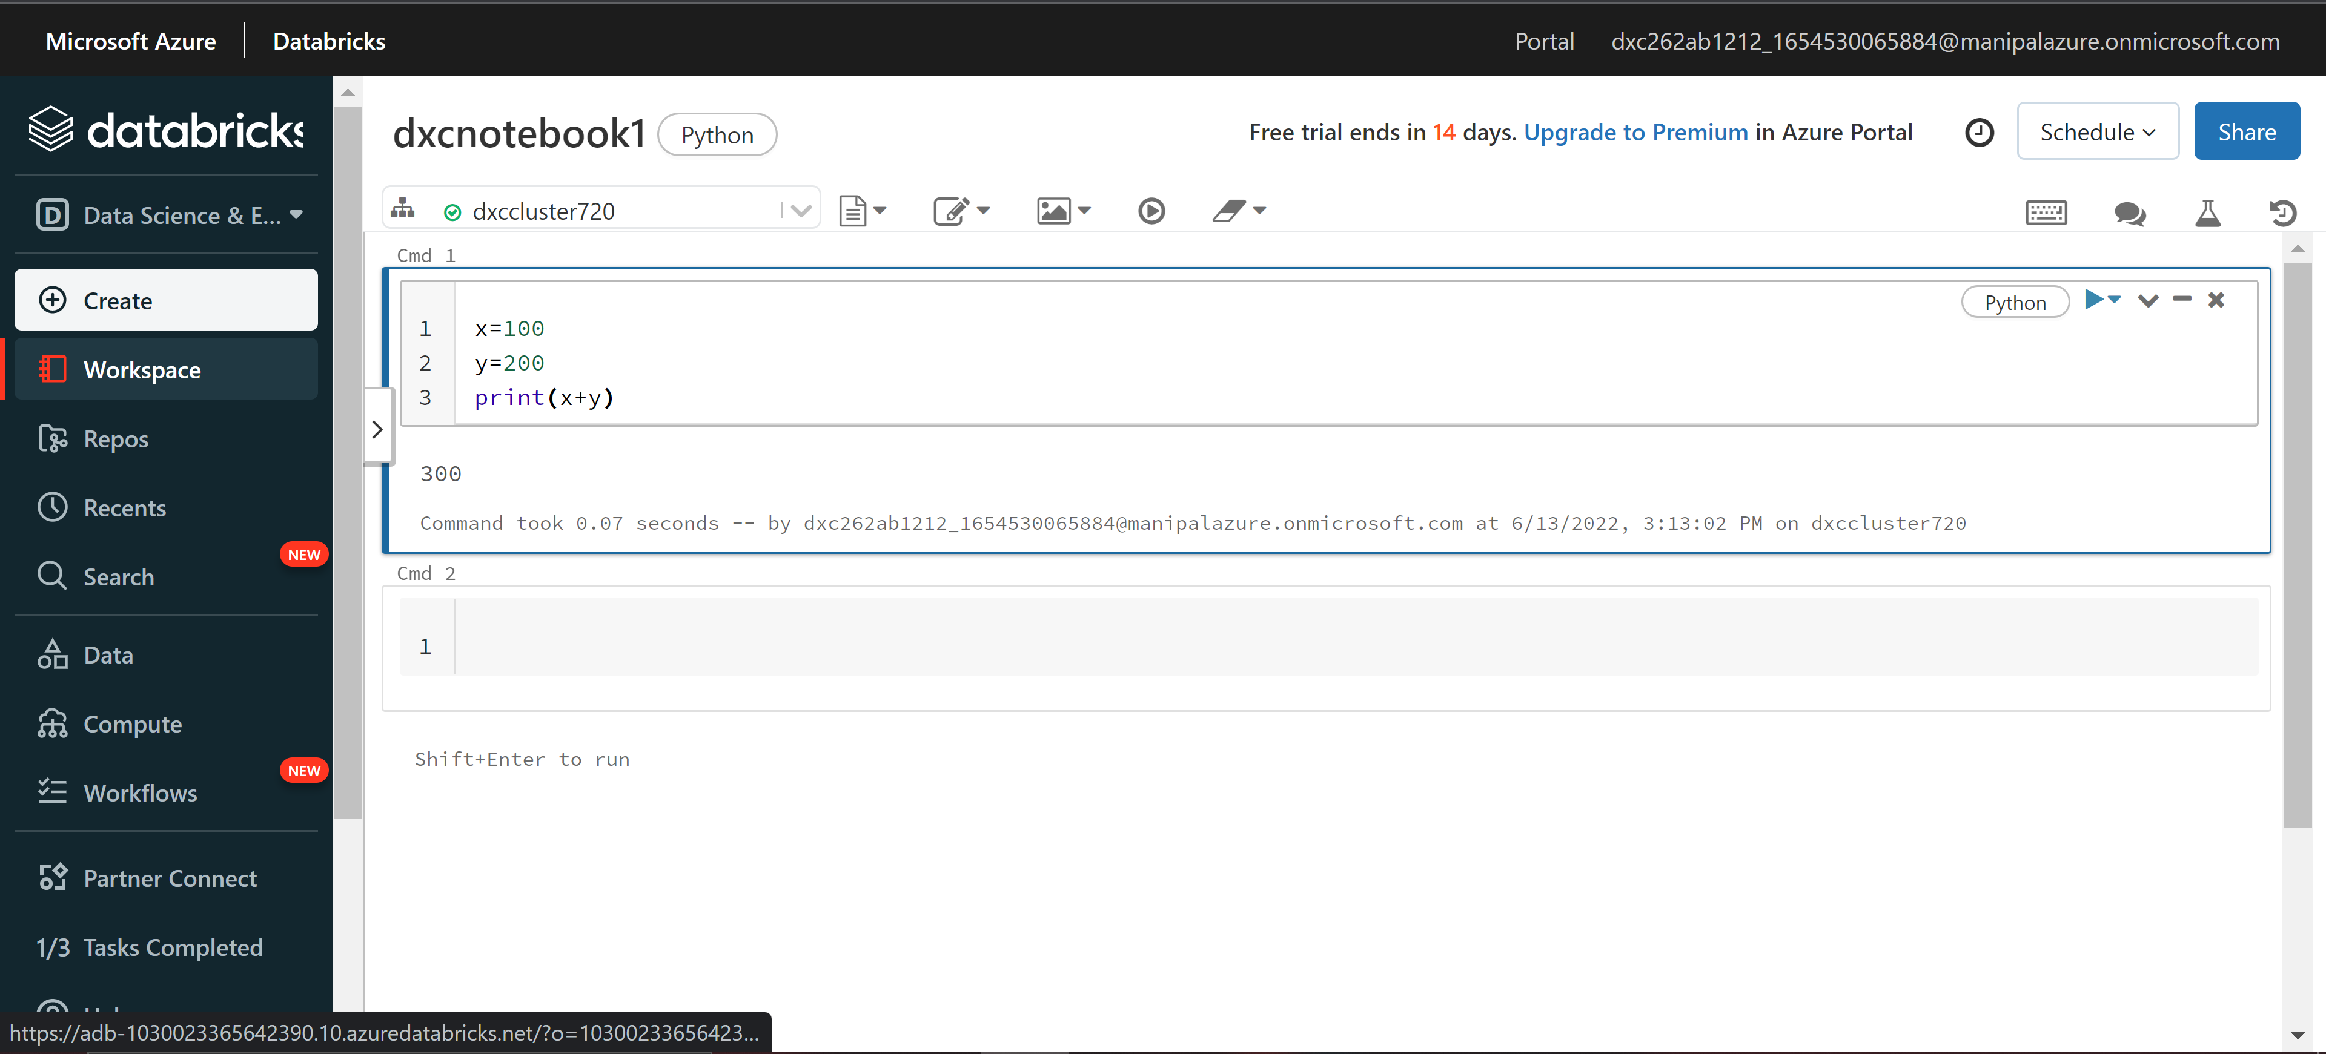

Practical Lab: **Azure Data Factory** For AP Morgan

Step-1: Goto azure portal and click on data factories and click on

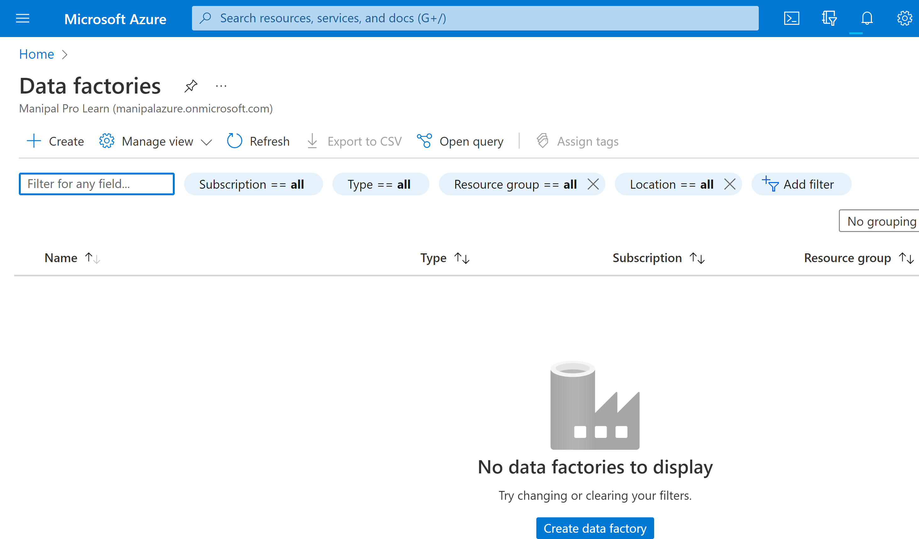

Step-2: Now Give required information and click on review + create.

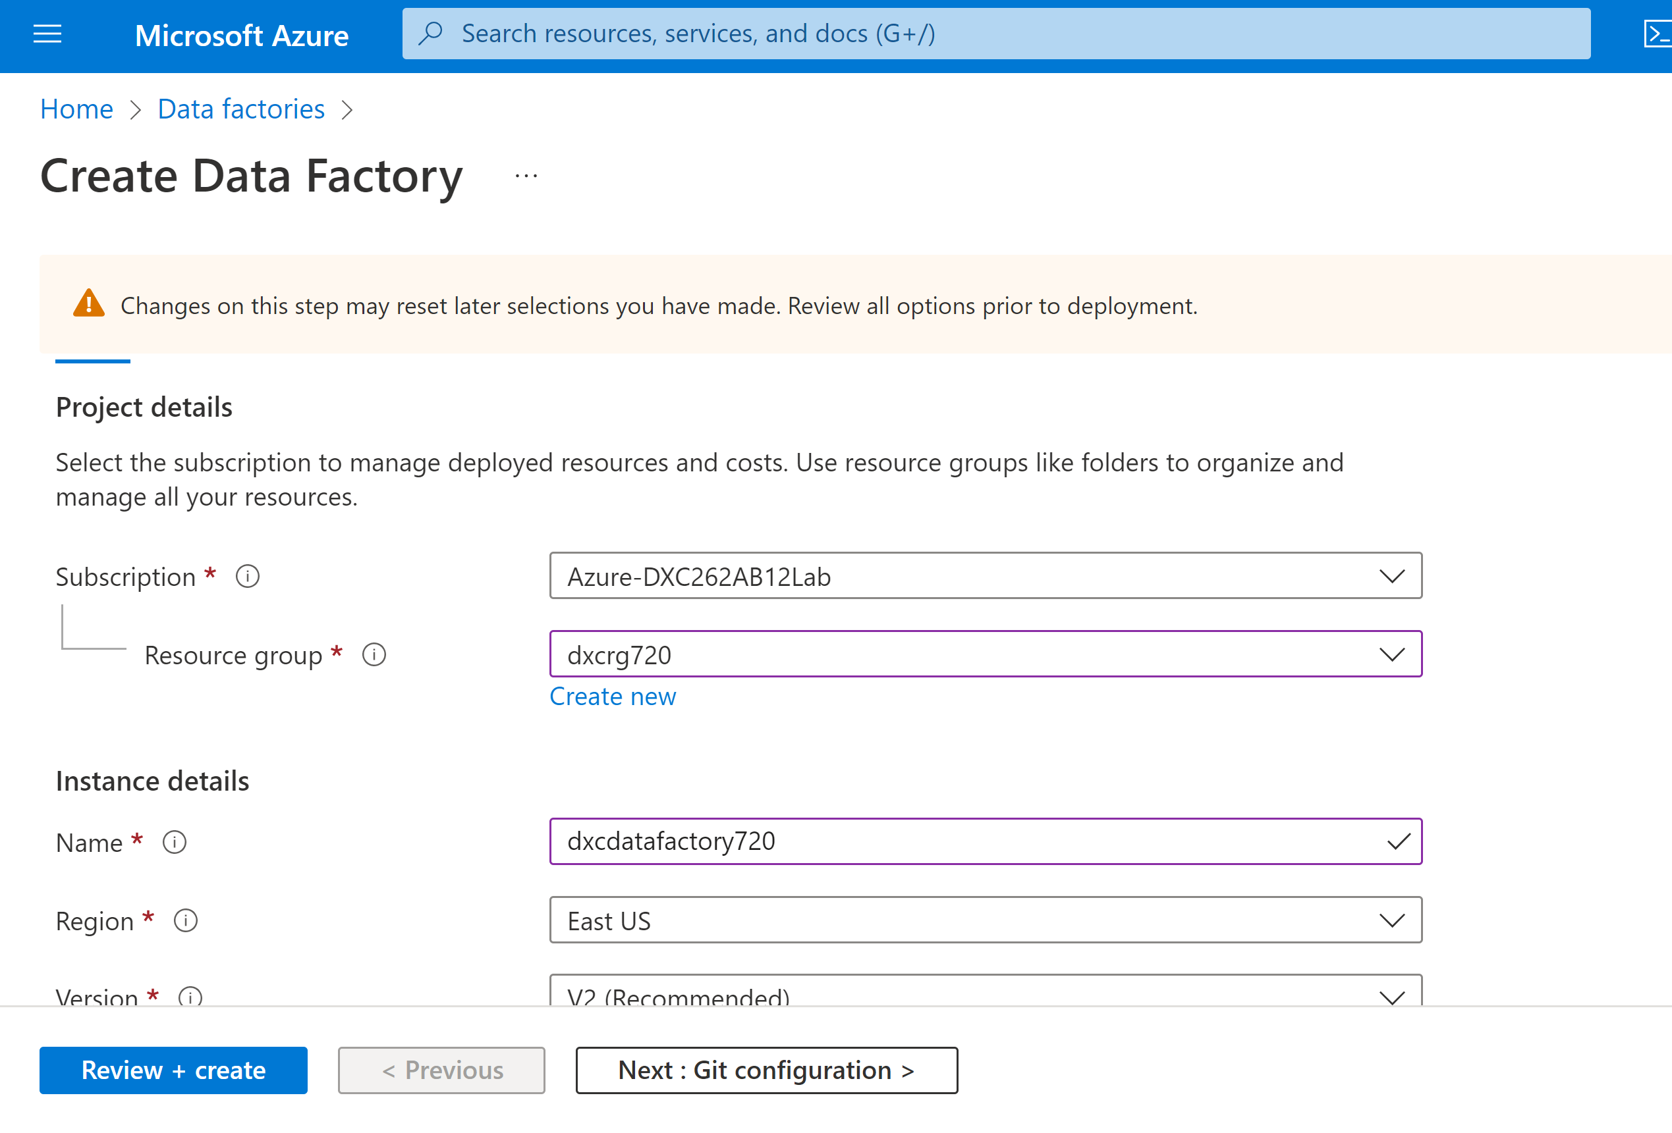

Step-3: After successful deployment goto Resources.

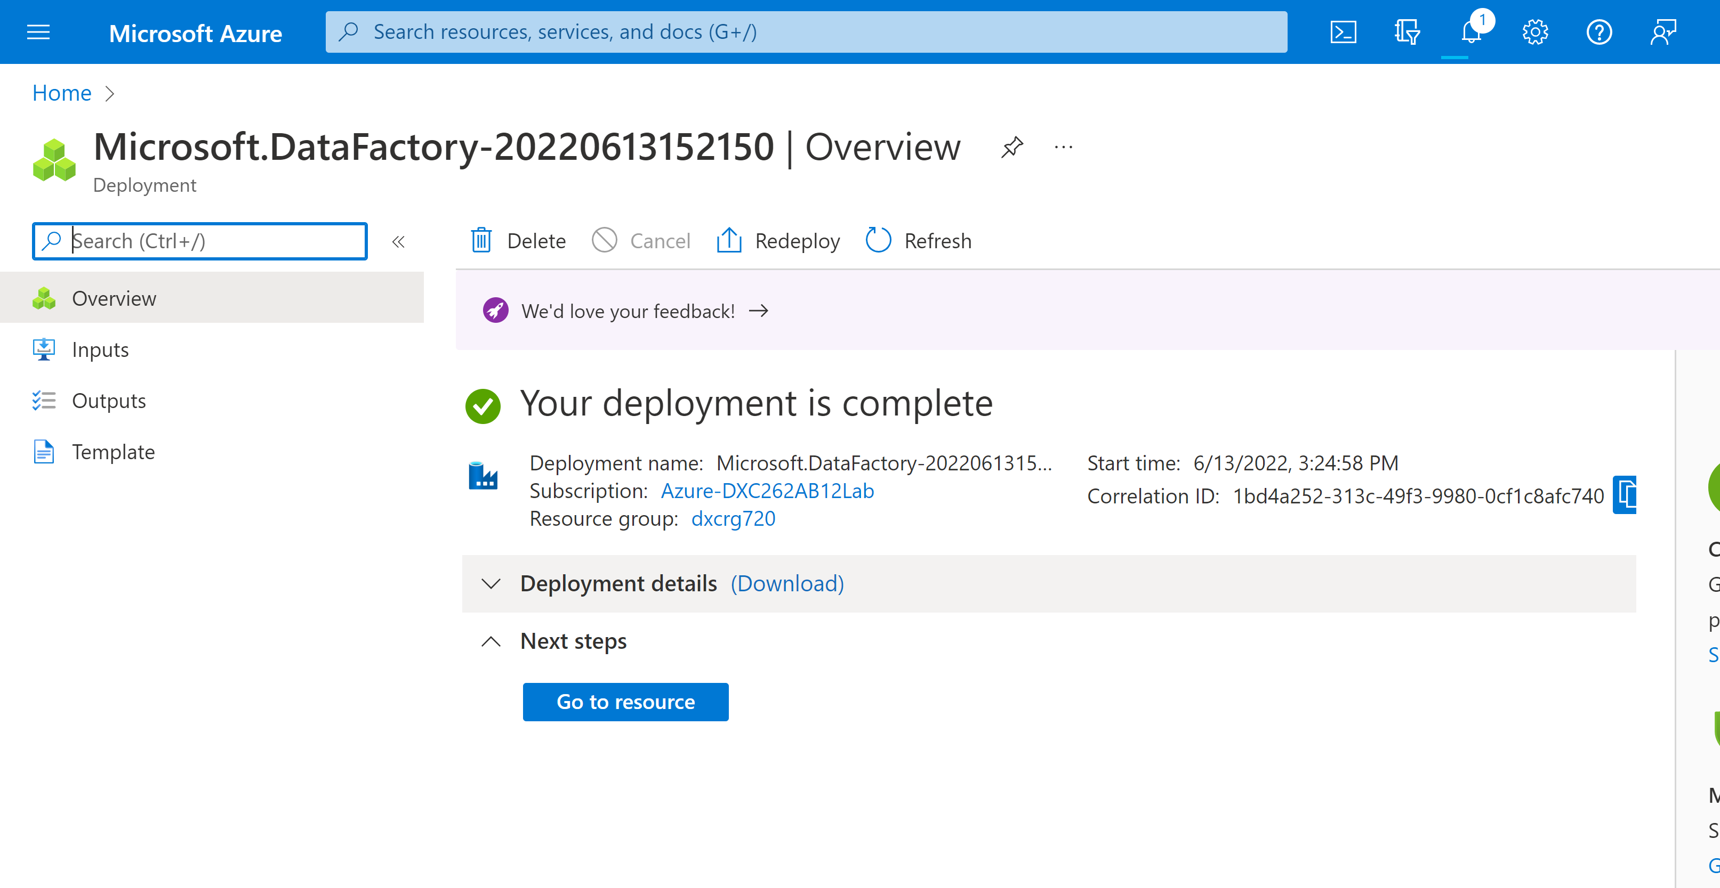

Step-4: click on open azure data factory studio.

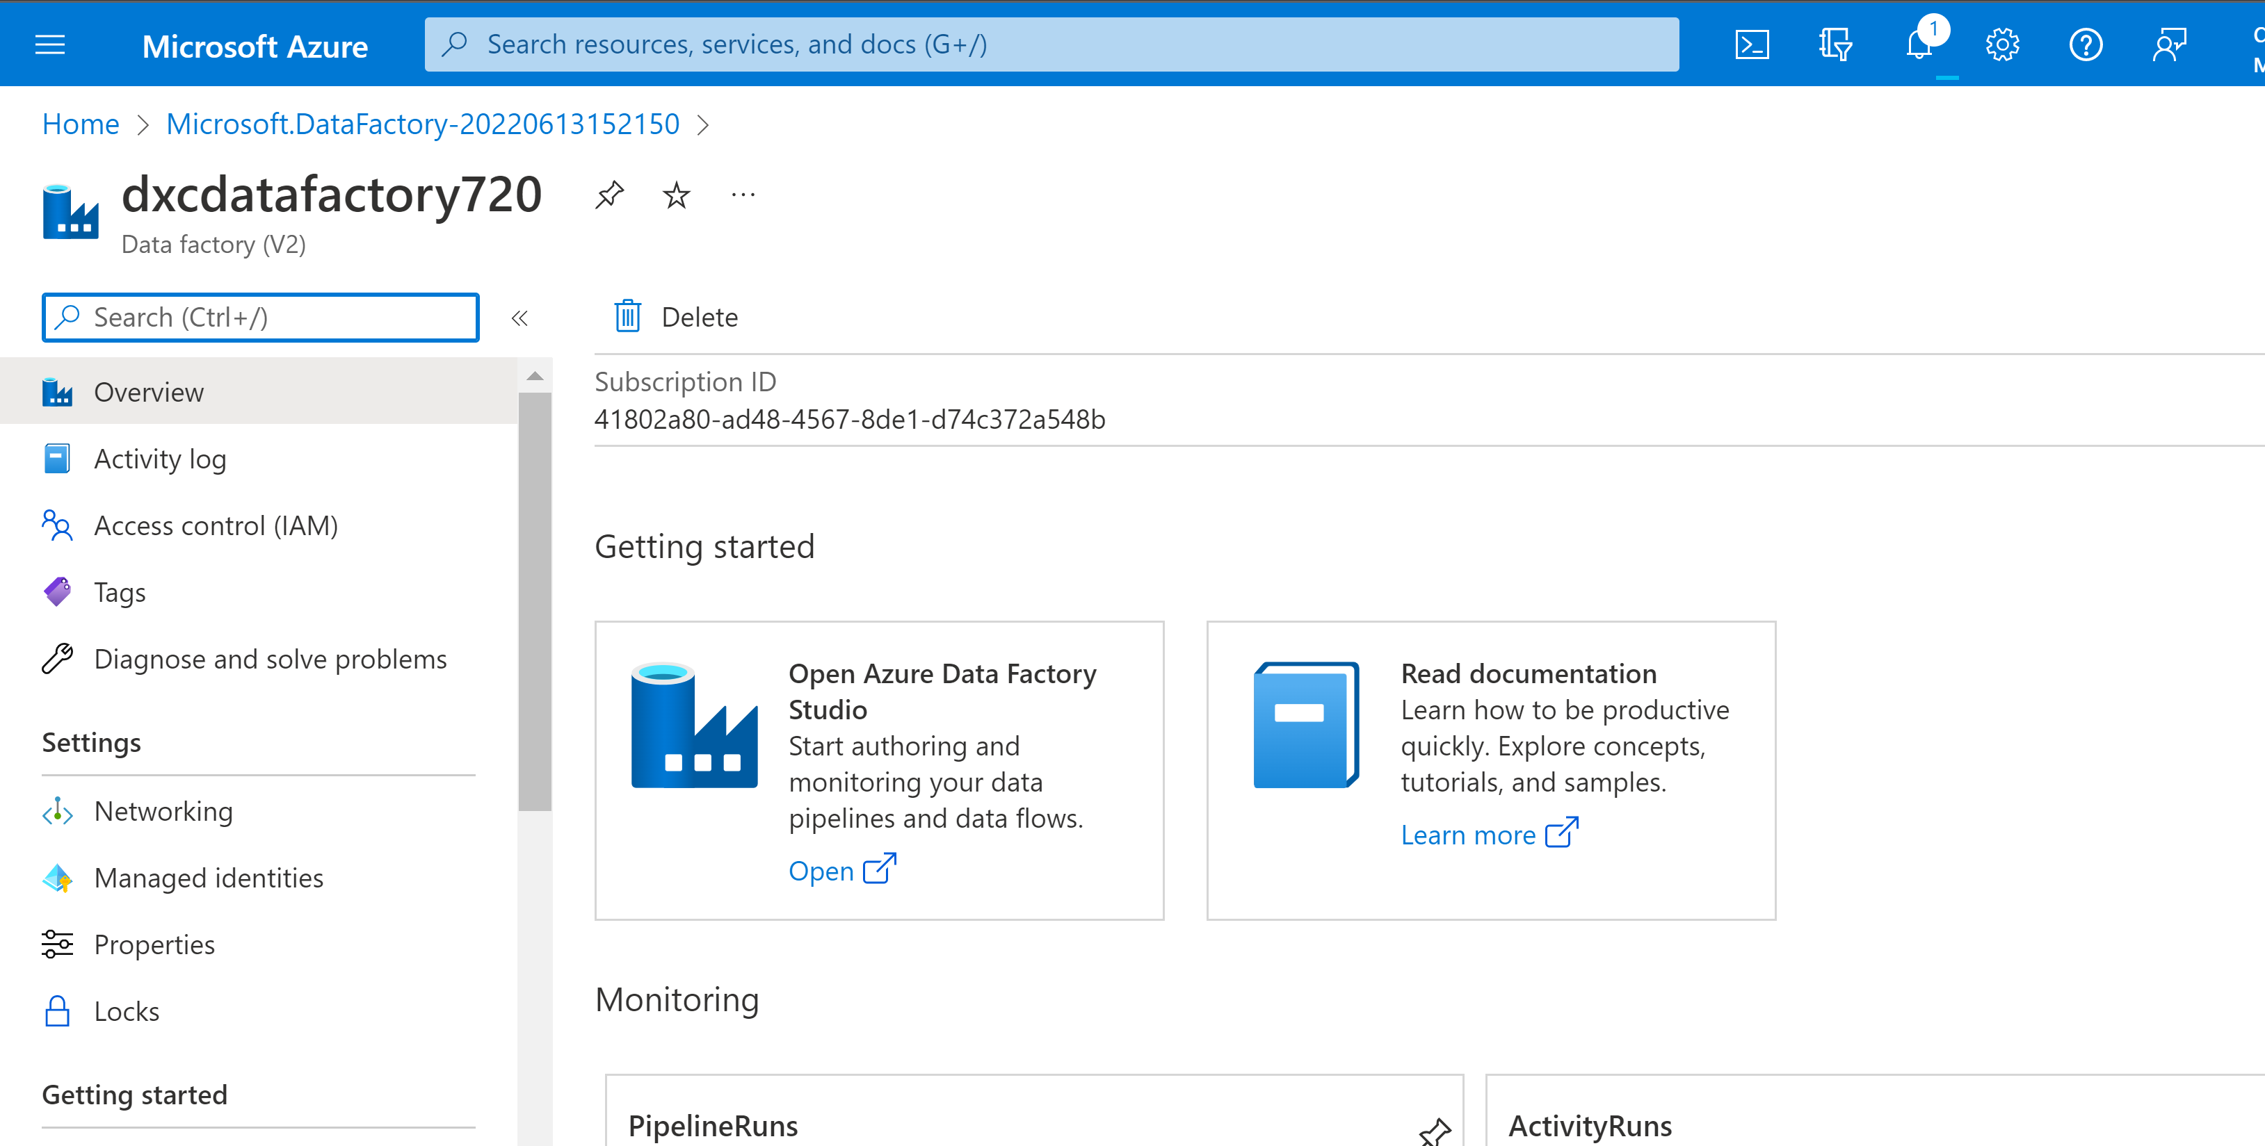

Practical Lab: **Create Azure Databricks** Linked Service in ADF

Step-1: First create new pipeline .

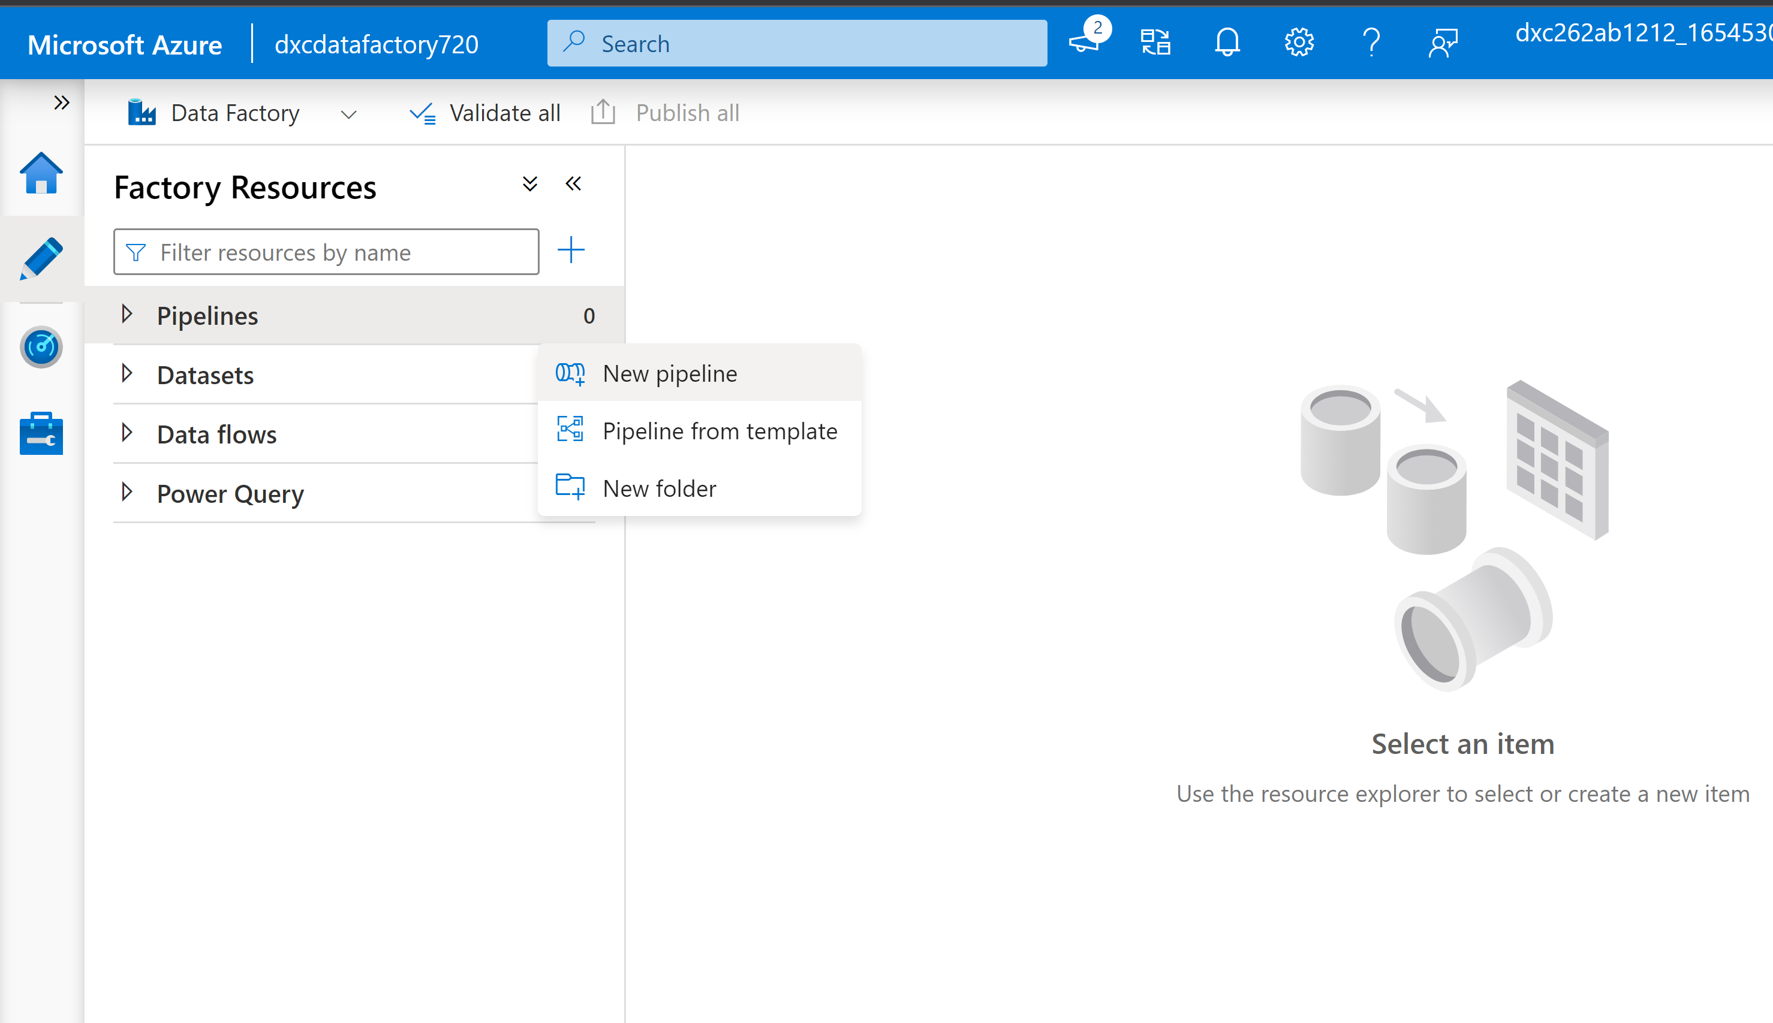

Step-2: now select notebook and drag it on to workspace.

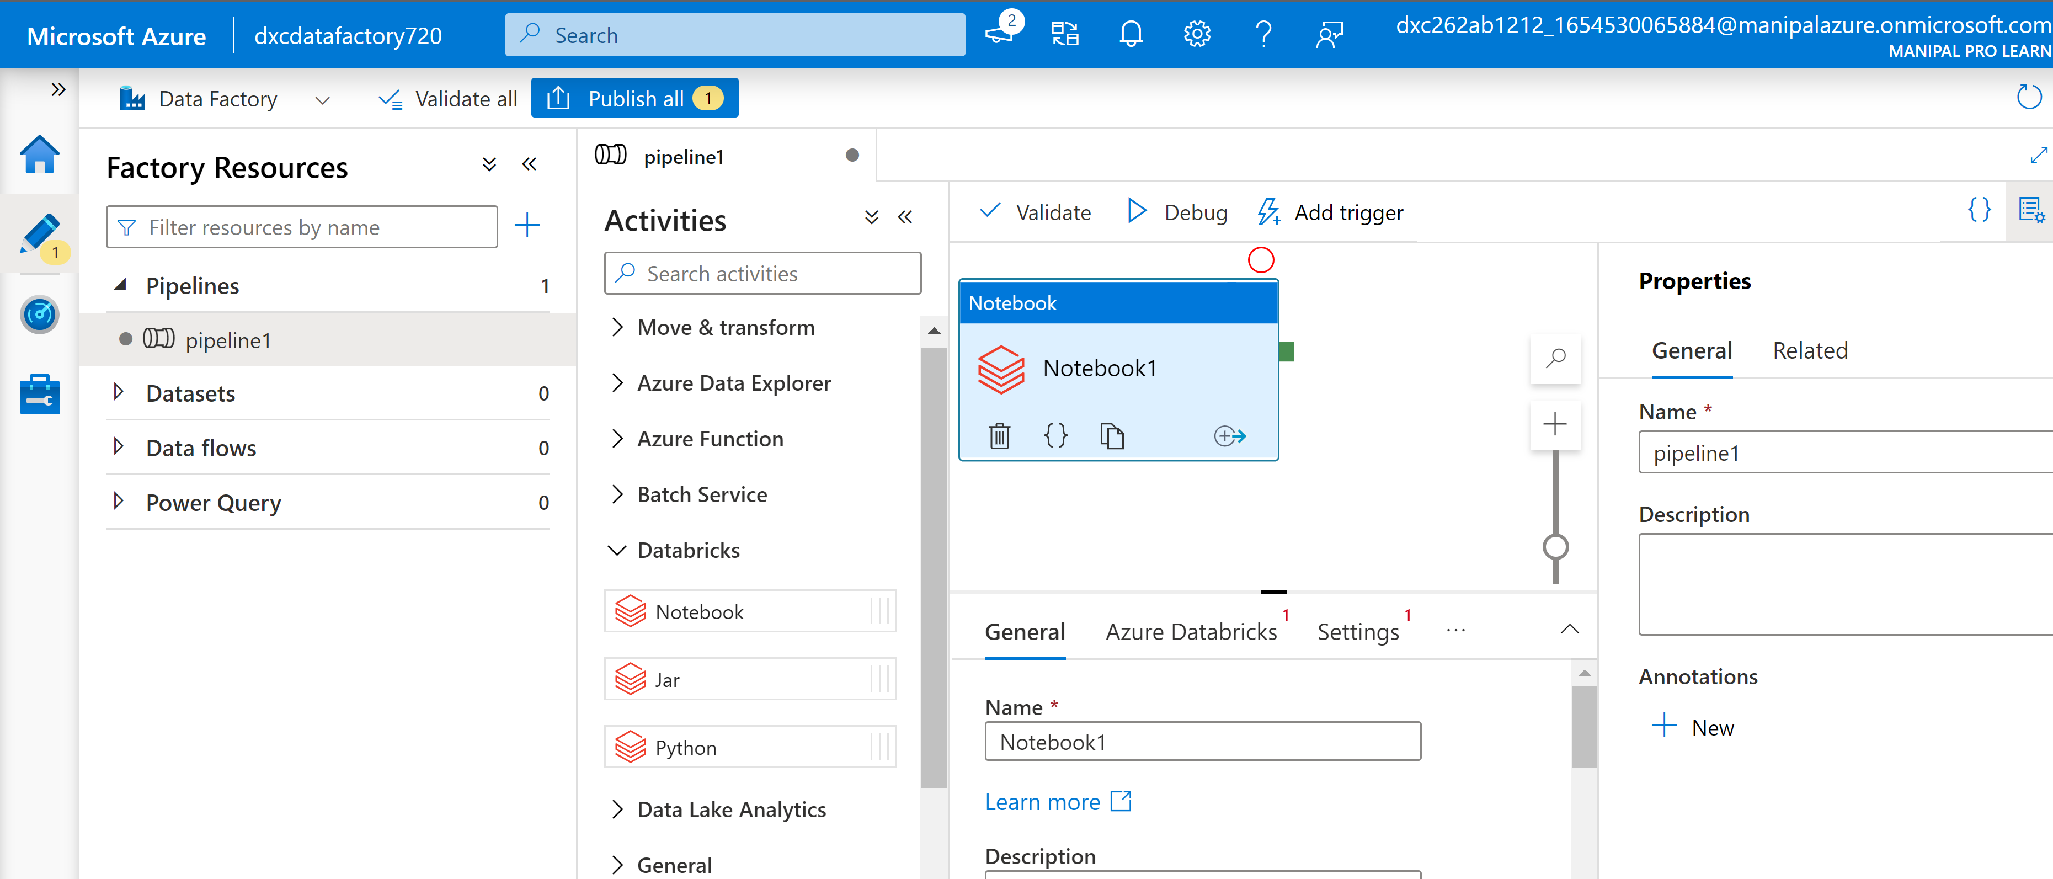

Step-3: create a new linked service .

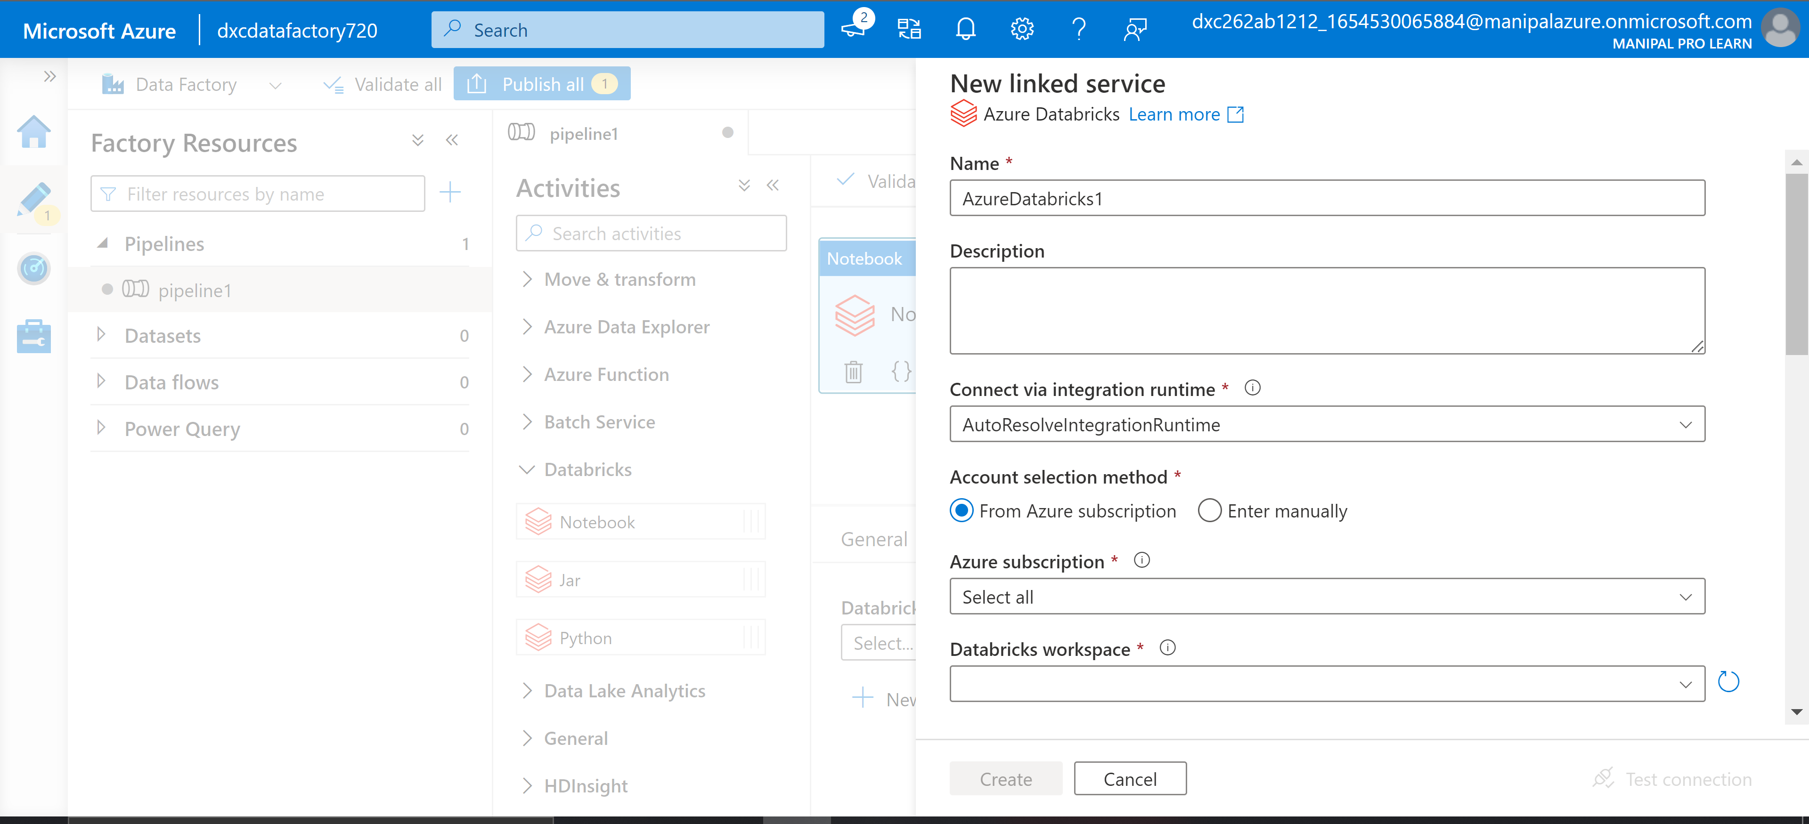

Step-4: Now we require a access token which we will be getting from databricks.

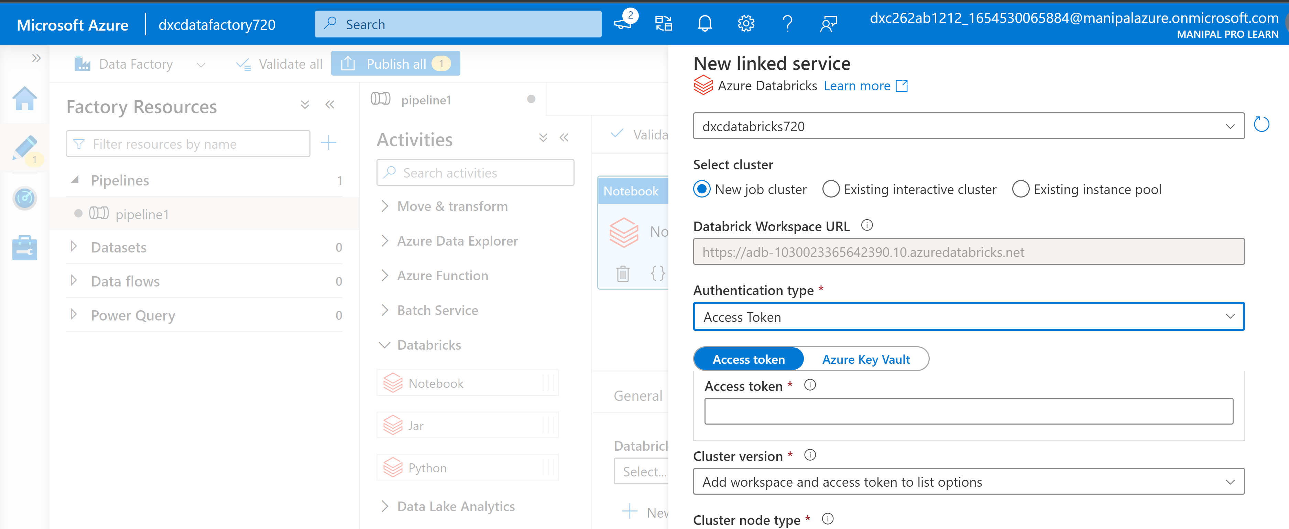

Step-5: In settings Goto User Settings.

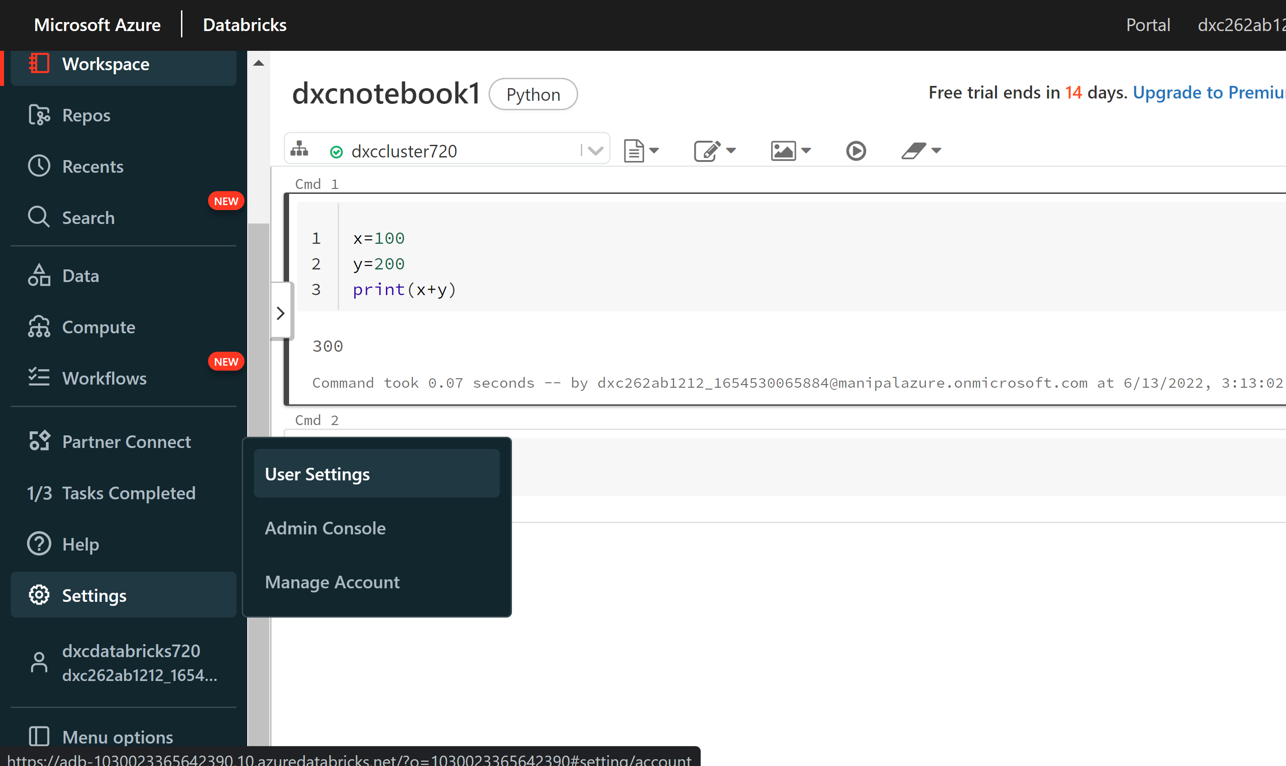

Step-6: click on generate token and fill required information and click on generate.

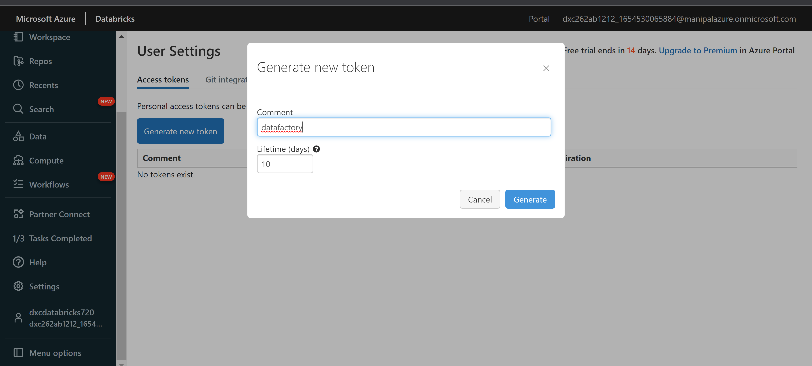

Step-7: now click on create .

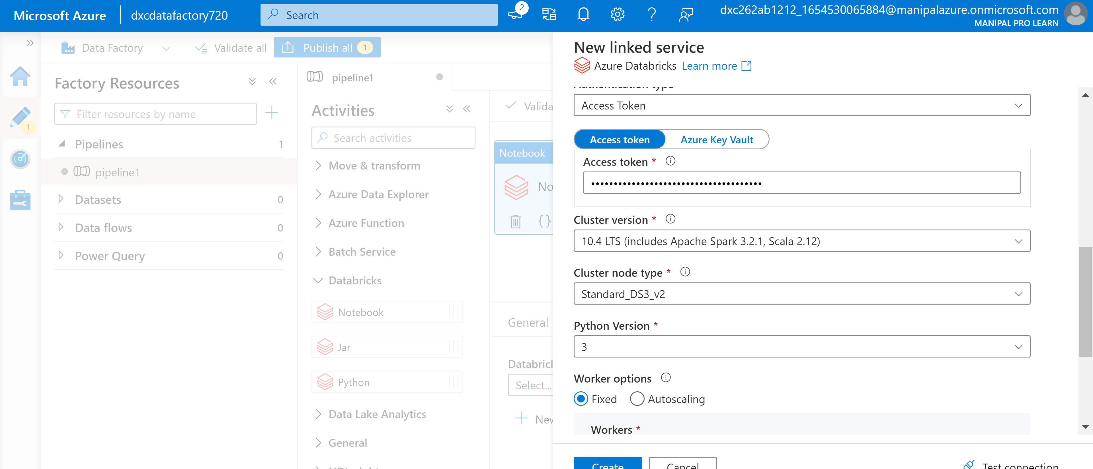

Step-8: Now select notebook path as mentioned in databricks.

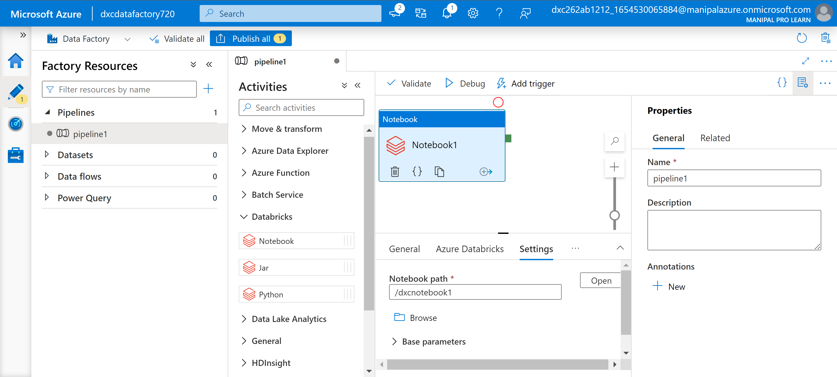

Step-9: Now click on publish to run the pipeline.

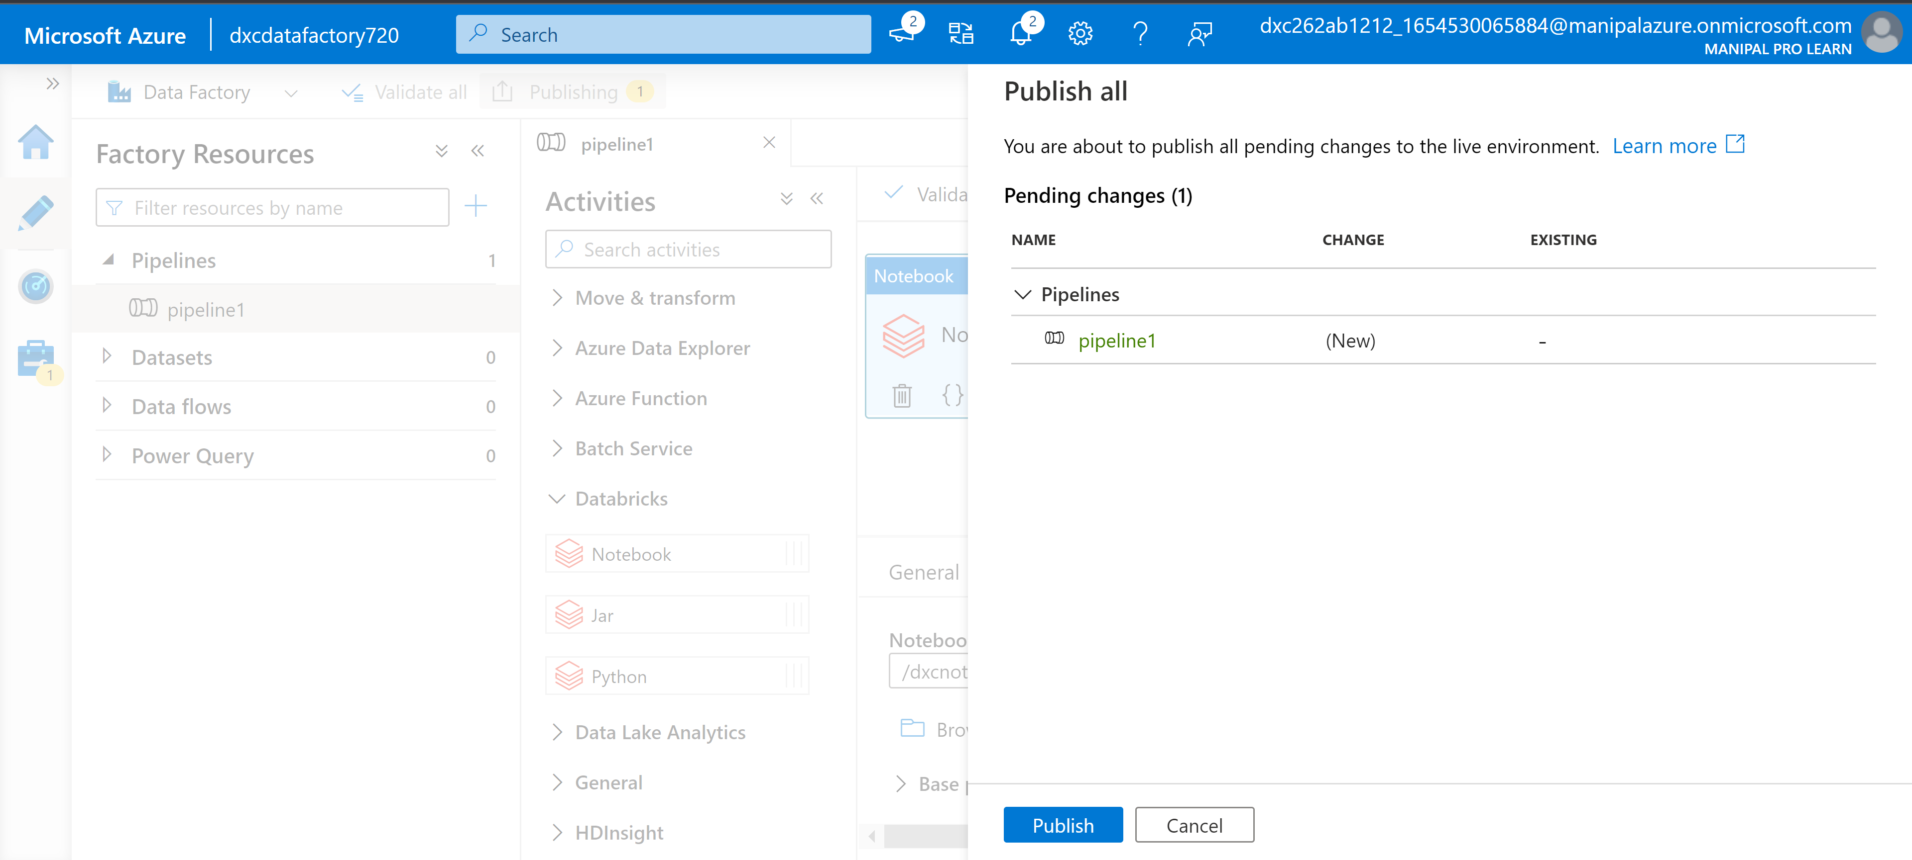

Step-10: Now we can check it’s status in monitor window.

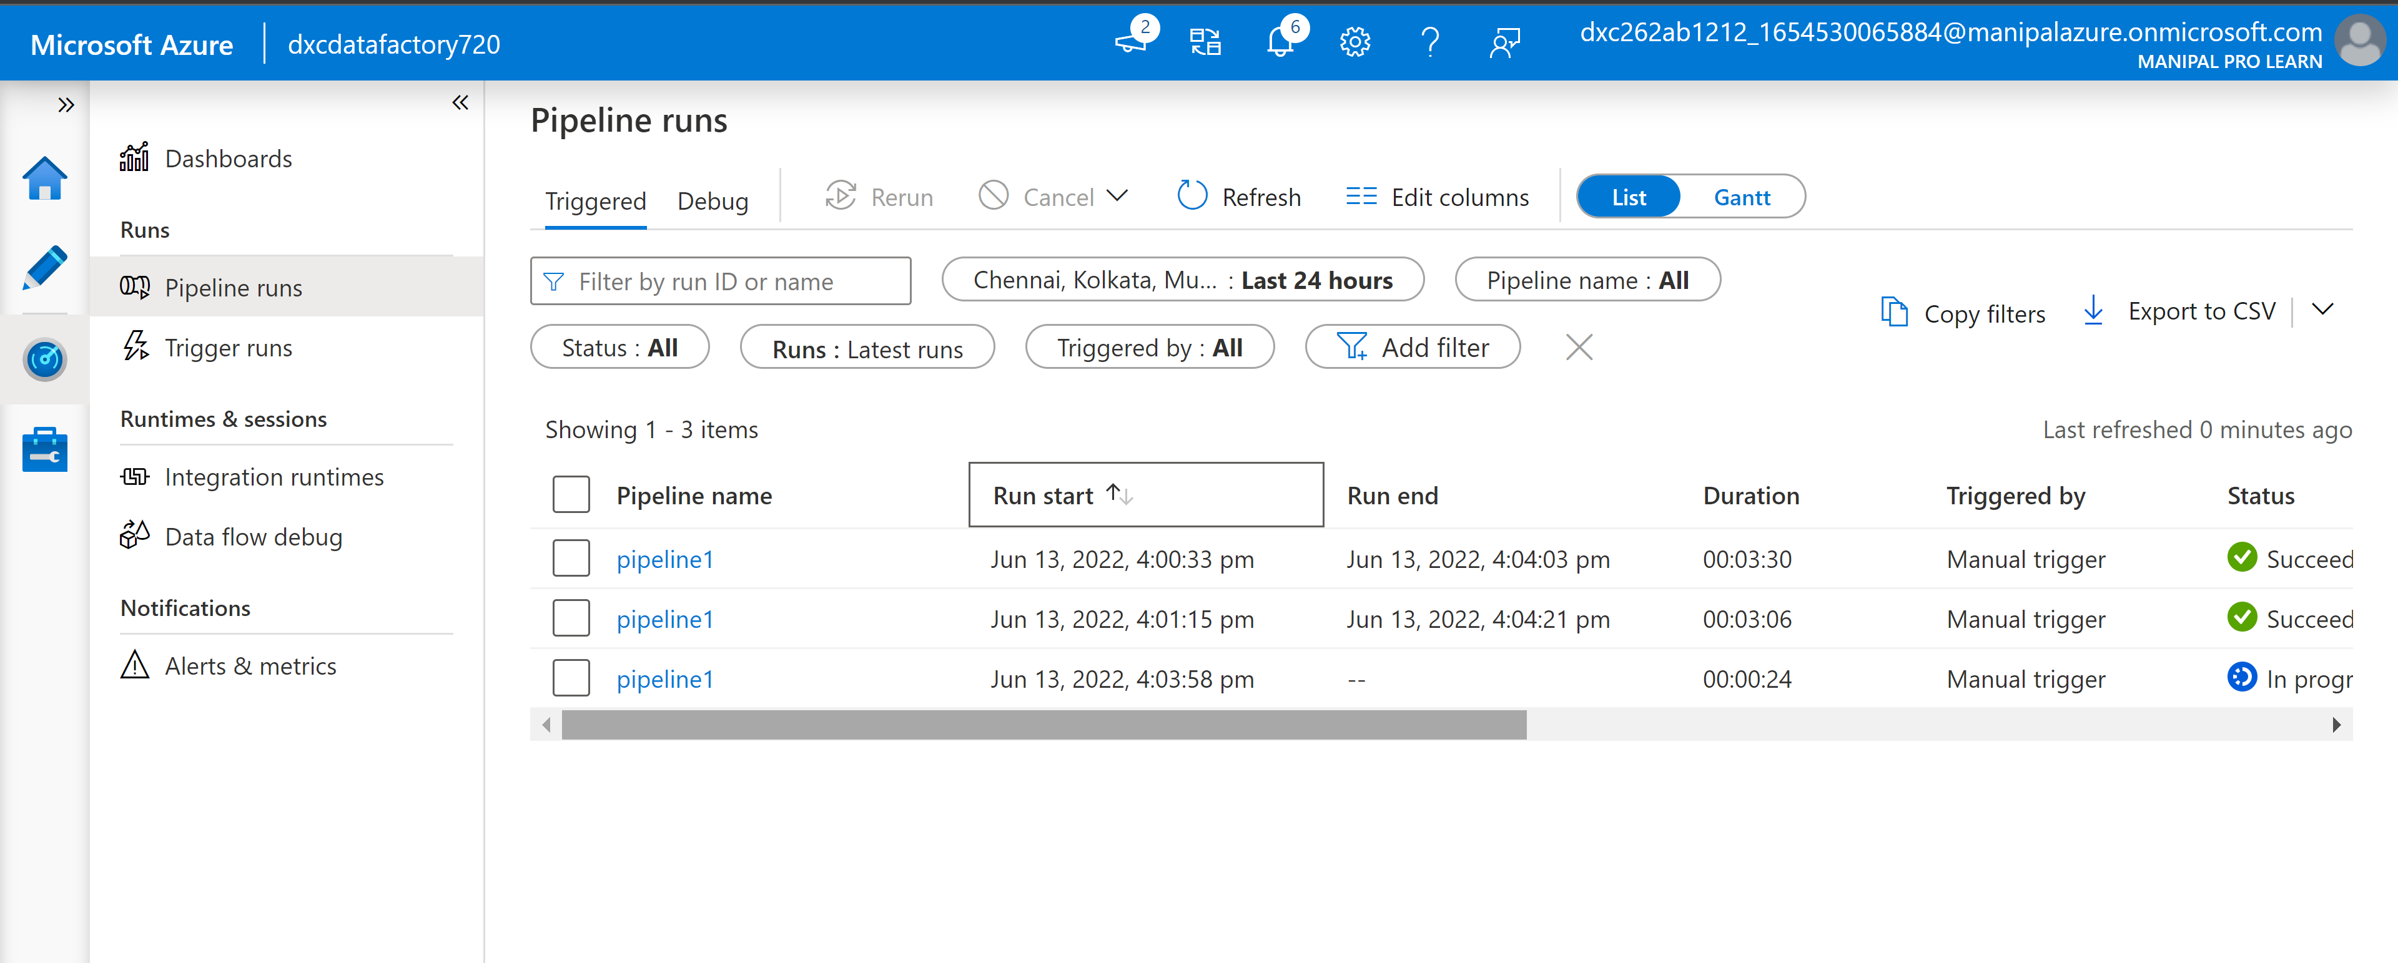

**Result:**

We are linking and triggering notebook of Azure databricks using Azure data factories.

**Conclusion:**

Notebook of Azure databricks is triggered by using Azure datafactories.

**References:**

* Microsoft technical documentation